**Post COVID-19: Will consumer behaviour patterns mutate?**

*With the COVID-19 pandemic changing life as we know it, it is inevitable that a new normal will emerge. This includes changes in lifestyle, and consequently consumer behaviours as well...*

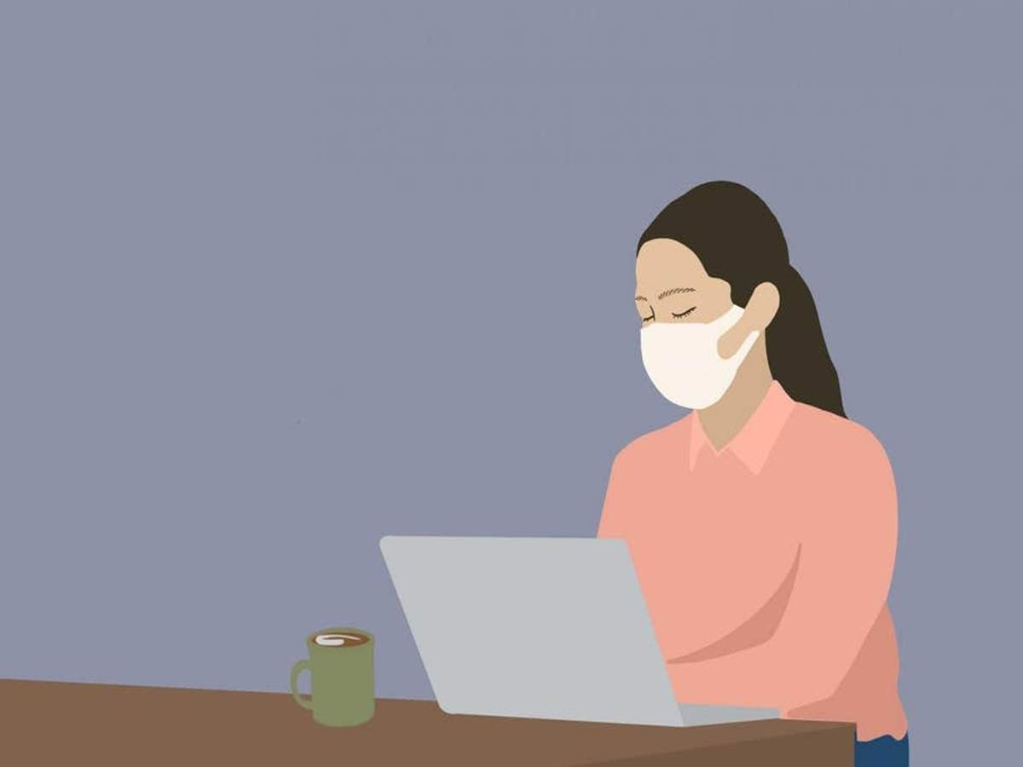Changing consumer behaviours in light of the COVID-19 pandemic.By [Dr Jones Mathew](https://brandequity.economictimes.indiatimes.com/tag/dr+jones+mathew)  
  
**Unprecedented Preferences Shift:** Covid -19 has done something which no amount of advertising by brands could do: it has made consumers change their ‘preferences’. ‘Preferences’ have never been easy to change; they are stubborn and often impervious to [marketing](https://brandequity.economictimes.indiatimes.com/news/marketing) communication pleas. But a pandemic changed the game faster than what brands could have ever imagined. Almost overnight, hardwired mall shoppers and reluctant fence sitters were pushed into the deep end of the online commerce pool. And in a matter of days there is a high level of dexterity and comfort in online shopping across the board. Will this new found environmental change mutate the mall crawling gene which consumers have had ever since retailing started? Will this shift to a different channel be permanent? Will malls and high street stores be reduced to mere show windows? Admittedly, it is too early to claim that, but with new hygiene and contagiousness concerns, it is possible that people will reconsider venturing into public domains such as shopping malls and movie theatres with the same carefree and reckless gusto as before. Or at least not as unarmed as before – now a bottle of sanitizer and a mask would be minimal essential weapons for anyone going anywhere outside of their homes. In addition there could be paranoia about the physical distance to be maintained with the nearest guy trying to be too social. Would retail sales persons need to pitch their voices louder and farther in times of physical distancing? Would there have to be teams to manage queues outside popular supermarkets as lines snake away? If demonetization jumpstarted the digital payments mindset in India, it may be safe to suggest that C-19 might change the way we behave as consumers.  
  
Read Also: <https://brandequity.economictimes.indiatimes.com/news/digital/sonal-dabral-to-chair-spott-awards-2020-jury/75347269>  
  
**The Virus as Catalyst:**The shift to digital had witnessed reluctant spurts from time to time but C-19 was the catalyst which online companies and ecommerce firms would have been praying for, although the mass mortalities and the contagiousness were not part of the bargain. Instead of an organic, gradual shift to digital, what crashed down on us was a tsunami of change. If and when malls do finally reopen, what are the likely changes that we could witness? First of all, it is generally agreed that the number of people who would visit physical retail would first spike as release from enforced [lockdown](https://brandequity.economictimes.indiatimes.com/tag/lockdown) happens which later on taper out and stabilize. But the new ‘normal’ is estimated to be lower than before as a new hygiene and mortality consciousness kicks in. Maybe governments and local authorities should control the release of people into retail locations systematically so that confidence in visiting retail establishments can resurface.  
  
**Consumer behavior and Culture:** Consumer behavior is influenced deeply by cultural factors. We are a social community with a high need for group activities – travel, tourism, shopping, religion, and entertainment. Festivals and rituals form a deep part of our religiously inclined psyche. C-19 lockdown notwithstanding, people have been known to conduct religious gatherings, wedding ceremonies and birthday parties even at the peak of the pandemic. These are aberrations, hopefully. Are they? In Kerala, the most well managed state in the C-19 fight so far with an excellent tracking efficiency and a mortality rate of just 0.58 percent (all India 3 percent and world average of 5.75 percent), on April 20 when the government partially lifted the lockdown there was a huge rush of humanity to city centres and shopping malls, so much so that the government there had to seriously consider the re-imposition of the lockdown.  
  
**Unsure Spending Power:**As a result of a new vulnerability to job losses and pay cuts, there will be lower spending at retail for some time to come, till sentiments climb back up. As jobs, increments, and promotions get the axe during the pandemic, the cheer needed for economy-pumping spending will be missing for some time. Brands must think of what can be done to bring optimism and positivity to how consumers behave after the virus is vanquished, or is in a state of suspended abeyance? It will always be good to have been a caring brand during the C-19 pandemic. If a retail brand puts profits above people, those people are going to remember the betrayal.If a retail brand comforted victims and took positive actions like making PPE kits, or N95 masks, or transported daily need material to needy areas it will be remembered to some extent as a sensitive brand –the cynics might say that all this is just eyewash – companies are never really for the customer, they are for themselves only. If companies did not lay off employees when they were the most vulnerable, or if they offered their factories and hotels to be converted into quarantine facilities, would they be remembered at all after the return to normalcy? Probably the new normal would be a tad different from the normal we knew. Or probably not. Nobody is clairvoyant enough to know that today. As a brand did consumers notice that it tried to be relevant to the survival struggles of citizens during the pandemic?If they did, it might determine to some extent what consumers think of you after.  
  
Read Also: <https://brandequity.economictimes.indiatimes.com/news/business-of-brands/jio-facebook-marriage-how-will-the-data-story-play-out/75327436>  
  
**Search for Optimism-filled Experiences:**After the long and indeterminate lockdown ends, retail brands must offer exhilarating and refreshing experiences to customers. There is going to be a psychological impact of this lockdown on people who relieve the stress to some extent currently by making “we shall overcome” videos and sharing Covid memes. For once they would have known exactly what “house arrest” means! The feeling of relief when the lockdown is ultimately lifted must be planned for in advance. The feeling will not be just about freedom of movement but also the exhilaration of having survived a diabolical killer. What as a retail brand are you going to do? Just join the band wagon of templated, me-too events or come up with some truly memorable and unique “victory over corona” adventures?  
  
**Hygiene as a Customer Attracter:** Consumer views about retail space cleanliness and employee and co-shopper hygiene is likely to play on retail shoppers’ minds for some time to come. We might feel socially awkward about suspecting everyone around us of being potential Corona carriers. And yet for our own survival, we might be forced to replace the handshake or a shoulder pat with an aloof smile. Stepping into a mall lift will be a mental challenge for many. Mall managers would have to ensure that such fears do not persist for long by constantly making health and hygiene assurances. [Consumer behaviour](https://brandequity.economictimes.indiatimes.com/tag/consumer+behaviour) must be engineered to tilt toward the old familiar as soon as possible.  
  
**The Long Term Game:**On the whole it will be better and wiser to play the long term game as a retailer in anticipation of consumers who might have changed visibly or surreptitiously forever by the corona virus. As a shopper whether some consumer behavior genes mutate or not only time will tell. Most consumers will be unsure of how to navigate a post [Covid-19](https://brandequity.economictimes.indiatimes.com/tag/covid-19) consumer world.They might be tempted to continue on the digital commerce journey forever. Retailers should be visionary enough and smart enough to help consumers navigate between online and offline experience journeys seamlessly by investing in an omni-channel world. Changes that were expected to gradually come upon us over the next half decade or so have been forced on both the consumer and the retailer like an oncoming express train.