Dirt is good - The value of dirt

[**Brent Gosling and Ranjit Jathanna**](https://www.warc.com/SubscriberContent/Article/OMO_Surf_Excel_Rinso_Breeze_Dirt_is_good__The_value_of_dirt/97635#about-the-author)



The WARC Prize for Asian Strategy, Shortlisted, 2012

**OMO, Surf, Rinso and Breeze are a franchise of detergents owned by Unilever in Asia; the brand name varies between countries.**

**How giving dirt a 'value' grew sales tenfold in Asia**

This was a case of how a single brand idea that used anti-detergent category advertising speak grew sales by over 1000% over seven years. For decades, communication in the detergent category had been a war of molecules. The category spoke the language of 'washes brightest, washes cleanest… whiter than the whitest, best stain-removal power… now with super-clean molecules… now with bigger molecules!'

The common perception was that dirt was the enemy and detergent X was the cure. In reversing this logic and making dirt 'good' in a mum's eyes – by showing her the life values kids learn and then exhibit through dirt – we were able to continuously grow the brand across Asia exponentially:

* The brand's sales in Asia grew tenfold. (Source: Unilever finance team.)
* We became the No.1 brand in most Asian countries, with market share reaching as high as 70%. (Source: Nielsen sales tracking data)
* Tracking scores on 'believe dirt is a positive part of life' continued to grow. Depending on the market, 60-80% of the target agreed with this statement. (Source: Millward Brown attribute tracking data)
* Brand bonding scores have increased across markets at an average of 30% ever since the launch. (Source: Millward Brown brand health data.)
* This idea has shaped positive action, from governments changing the school curriculum and including more time for play (Vietnam) to introducing parks for children (Vietnam, Thailand) and more.

**Market background and business objectives**

OMO, Surf, Rinso and Breeze are a franchise of detergents (depending on the country you live in) unified by the single ideology 'dirt is good' (DiG).

The idea was first conceived in the late '90s, and rolled out in the Americas. The idea was decoded as 'dirt = experiential learning = good' and brand shares increased instantly. As a completely counter intuitive way to look at detergent communication, the idea that dirt is good needed to land in the developing and emerging (D and E) world. But landing it was going to be more challenging than we thought!

**The challenge**

Dirt is seen as bad in Asia. Dirt equals poverty, squalor, poor hygiene, hardship, disease and sometimes death.

Add to this years of messaging to propagate good hygiene by the likes of the World Health Organisation, Unicef and, indeed, massive D and E brands like Lifebuoy and Dettol, which had convinced mothers that dirt was bad and best avoided.

The challenge the team had to grapple with was finding a new meaning for dirt that made it good in the eyes of the D and E mum. We knew from the Americas that those who bought into the philosophy of dirt being good, tend to buy into the brand. Our objectives for Asia were:

* Double brand proceeds from sales over a five-year period by growing volume
* Make 'dirt is good' a top-two player in each market of Asia where it exists, in terms of value and volume
* Establish the philosophy of 'dirt is good' by getting mums to agree with a tracking measure of 'getting dirty is a positive part of life' with at least two in 10 mums agreeing with this statement
* Establish the brand's 'cleaning' credentials with consistent growth in the tracking attribute 'cleans clothes thoroughly'
* Increase bonding with the brand by at least 10-15% over a period of five years.

So was there an angle, a philosophy shared in the D and E markets that could allow dirt to become 'good' in mums' eyes and help us to achieve our objectives?

**Insight and strategic thinking**

Our target was mums in the developing and emerging markets of Asia that believed:

* Dirt is bad
* Allowing their kids to get dirty was 'not a positive part of life'. They rejected dirt and anything else that they deemed unhygienic.

**The breakthrough**

Surely there must be something that makes getting dirty more relatable and acceptable to people in this part of the world? We began to investigate the issues and barriers to accepting this philosophy – meeting mums across key markets, interviewing psychologists and observers of parenting trends. Through this deep-dive, breakthroughs came by exploring how to bring the idea to life specifically for audiences in each market. We began to explore smaller, more intimate human insights in a search for a pay-off that mothers would wholeheartedly endorse. How exactly was it good to get dirty?

**The insight that made dirt 'good'**

Mums in Asia shared a deep-rooted fear of their kids forgetting the cultural values that her generation had cherished. Worried that modern living was not encouraging these values to be passed down, they welcomed any vehicle that might help them do this.

**The strategic steer**

So to make getting dirty 'good' for mums, we needed to make the act of the child getting dirty purposeful. The purpose needed to be rooted in Asian culture, beyond the western world's view of skill development and general learning. The act of the child getting dirty must be through displaying 'values' that mums in these markets cherish.

With this in mind, we led a decoding of Asian values. What do mums find intriguing, genuinely persuasive or more fulfilling? This was interpreted both from the macro Asia perspective as well as a micro country perspective. Values of 'forgiveness', 'sacrifice', 'gratitude', 'courage', 'determination' and many more became the cornerstone for communication development and the heart of all DiG stories in these markets. So while the west interpreted the idea of DiG in a 'skill development and general learning' way, we interpreted DiG as displaying life values that mums cherish in Asia. When mothers saw that getting dirty could help children practise those lifetime values that she believed were important, then the experience might just offer some real gain for the child. And instead of trying to convince her about the logic of 'dirt is good', our advertising concentrated on portraying the benefits of getting dirty in an engaging and charming way.

Here's where we saw a strong role for the brand – a child's experiences could be equated to learning the values of life. The brand's viewpoint became: 'If getting dirty leads to your child learning and exhibiting life values, then dirt is good'. With this lens, we were a mum's ally in imparting great values to her children. Through numerous integrated campaigns that expressed this viewpoint through the eyes of her child's development, we were able to reach out and join hands with these mothers

**Implementation, including creative and media development**

**In countries like India:** Mothers place great worth on the harmony of their family, and filial love and care. Here we launched 'Dirt is Good' with an execution where a little boy gets dirty by 'punishing' a muddy puddle that has dirtied his sister.

**In countries like Thailand, Indonesia and Vietnam:** Simple stories of generosity and consideration worked particularly well – a boy who makes a birthday cake for his mother, for example, or kids coming together for Tet (Vietnam's Lunar New Year) celebrations.

'Dirt is Good' has been a great storytelling campaign and, as such, TV was always the main medium through which it was brought to life.

That said, the power of 'Dirt is Good' has been built through a variety of other media as well. PR played a powerful role in the launch for each of the markets, by promoting the implications of the philosophy and encouraging national debate. The campaign continues to be supported by both traditional and online media, as well as a wide range of activations to bring its impact alive for millions. From the Kala Goda children's festival in Mumbai to new play parks in Thailand, DiG made itself present in the schools and streets of the developing world. Thanks to seasonal sponsorship in Vietnam, OMO is now the brand most associated with its Tet celebrations.

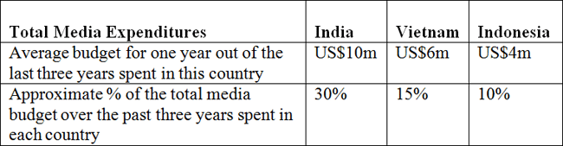

**Performance against objectives**

In measuring the long-term impact of this campaign, we will not report on the individual targets for each execution, but instead will aim to demonstrate the strengthening of market share that has been created by the campaign over the course of the time it has run.

Of course, market share is influenced by a number of non-communication factors, so one of the intermediate metrics that we used across all countries was an evaluation of brand health. The Millward Brown brand dynamics tool provides an assessment of brand strength based on its laundry-tracking data. It gives metrics for brand loyalty derived from a quantification of the strength of consumers' relationships with a brand. The strongest brands are shown as those with the highest percentages of people recognising the brand's advantage, and ultimately the proportion of the audience 'bonding' with the brand.

At an immediate level, the advertising plays a key role in driving the attributes associated with the brand. With the objective of trying to convince consumers of our functional superiority, the third metric we tracked was belief in its cleaning performance. This was captured by Millward Brown's tracking, which monitors agreement with attribute statements. Of these, the most basic reflection of trust in the brand's ability is 'cleans clothes thoroughly'.

**Snapshot**

Six years after the launch of the idea across Asia, the brand continues to grow exponentially:

* The brand's sales in Asia grew tenfold. (Source: Unilever finance team.)
* We became the No.1 brand in most Asian countries, with market share reaching as high as 70%. (Source: Nielsen sales tracking data)
* Tracking scores on 'believe dirt is a positive part of life' have continued to grow. Depending on the market, 60-80% of the target agreed with this statement. (Source: Millward Brown attribute tracking data)
* Brand bonding scores have increased across markets at an average of 30% ever since the launch. (Source: Millward Brown brand health data.)
* This idea has shaped positive action, from governments changing the school curriculum and including more time for play (Vietnam) to introducing parks for children (Vietnam, Thailand) and more.

**Overview**

**Sustained growth in brand bonding**

The Millward Brown brand dynamics measure of ultimate brand commitment, brand bonding, has increased in all cases since the launch of 'Dirt is Good'. In the other countries, this measure was not introduced until 2008, but since then it has strengthened in all markets to date. In Vietnam it has grown from 66% to 74%, in Indonesia from 38% to 52%, and in India from 22% to 24%. Our target was 10-15% in Asia, but we have exceeded this with an overall growth average of 30%.

**BRAND BONDING 2008 vs 2011**

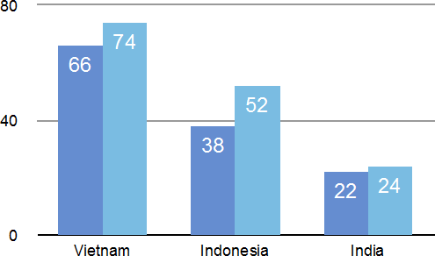

*(Source: Millward Brown tracking data)*

**Sustained growth in agreement (attitude change) of the 'Dirt is Good' measure**

Tracking scores of 'getting dirty is a positive part of life' have been improving continuously, so the belief in the brand philosophy is getting stronger every year. Depending on the market, 60-80% of the target agrees with this statement. Our target was to get at least two in 10 mums agreeing with this statement, but we have exceeded this across the markets with six to eight mums in 10 now agreeing with the statement.

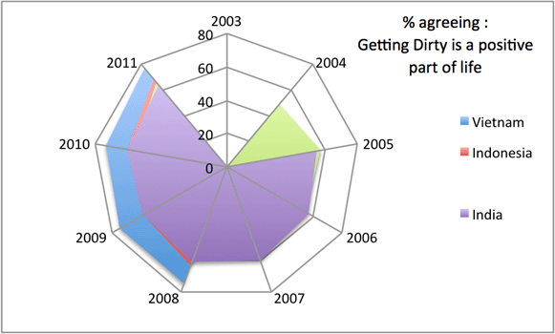

*(Source: Millward Brown tracking data)*

**Sustained growth in cleaning attributes**

During the process of monitoring this campaign changes have been made to the methodology, so we only have comparable data from 2008 onwards. Here we can see how the brand has developed a considerably far stronger reputation as a brand that 'cleans clothes thoroughly'. This campaign has not only been successful in reinforcing DiG's superior cleaning credentials against a barrage of competitor's molecular claims, it has built stronger emotional bonds with its users and grown its market share as a result.

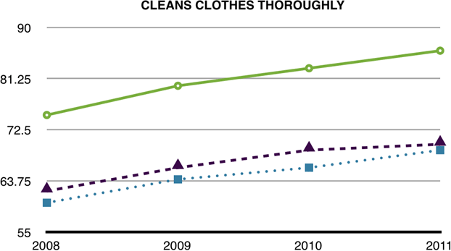

*(Source: Millward Brown tracking data)*

**Sustained growth in market share**

We have used three markets to illustrate the impact of DiG. To put this into context, pre-campaign the increasingly competitive market conditions had resulted in DiG's market share growth stagnating across the three markets. Post-launch, volume market share had jumped up to unprecedented levels.

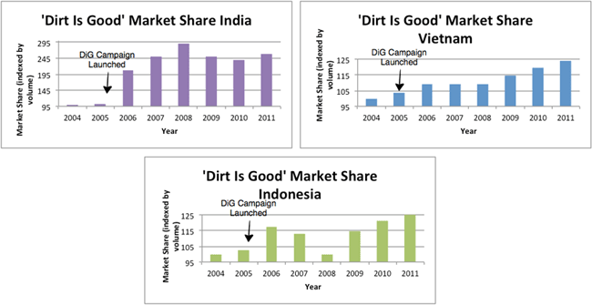

*(Source: Nielsen sales tracking data)*

To preserve confidentiality, this data is shown by country, and by year, as an index in the graphs above. As can be seen, DiG has grown its share of the market year-on-year. This, we believe, is clear evidence that in the fastest-growing markets, against the leading detergent players in the world, adding 'values' to the brand idea gave DiG the edge. Our objectives were to double brand proceeds from sales over a five-year period by growing volume – which we not only exceeded by growing it by over 1000%, but also sustained it.

Value share grew in line with volume share, demonstrating that gains were not made simply by lowering price. The only exception here is Indonesia, where a pricing battle lost the brand both value and volume share in 2008, but this was recovered in 2009 and was at its highest level in 2011.

DiG is an emotionally led campaign in a highly competitive and commoditised market, which turned the market's scientifically based 'laboratory demonstration' style of advertising on its head, and in so doing delivered impressive and sustained market share gains over an extended period.

The annual brand value sales in Asia have grown tenfold from the time the campaign first broke here – that's an increase of over 1000%. DiG is now the biggest detergent in the D and E world.

But the 'marketing with soul' result for us is the cultural shift we continued to make in children's lives – the fact that more mums in Asia have changed their attitude and now see dirt as 'a positive part of her child's life'.

Top of Form

Bottom of Form

[**www.warc.com**](https://www.warc.com/)

All rights reserved including database rights. This electronic file is for the personal use of authorised users based at the subscribing company's office location. It may not be reproduced, posted on intranets, extranets or the internet, e-mailed, archived or shared electronically either within the purchaser's organisation or externally without express written permission from Warc.