Royal Enfield. In the 2019 Global Sales down 18% despite booming in Europe

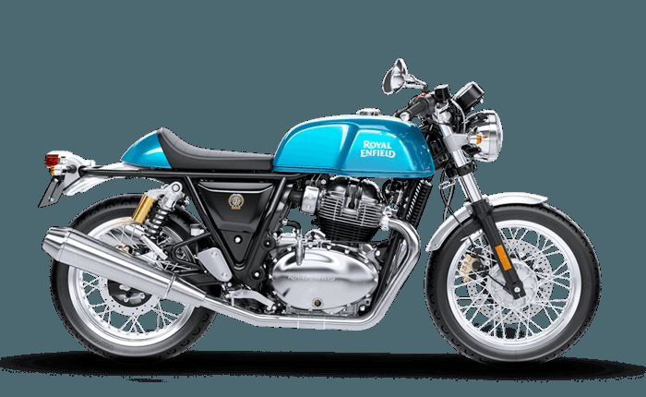

**Royal Enfield**has lost a deep 18% of sales in the **2019** following sixth consecutive all time record years. Sales are fast growing in all regions, but in India, which dragged down the global performance. In Europe sales are booming in all countries and UK become the second market worldwide. Good score in Argentina and Colombia as well

### **Global Sales**

**Royal Enfield** is running hitting record sales year after year, expanding the global distribution, image and customer base, while keeping live one of the oldest line-up actually in the World. They have been able to generate values remaining “old” in a World driven by youth.

**Royal Enfield** recent years sales score is impressive, having benefit from the boom of Indian market, where Royal Enfield is – by far – the leader in the mid-engine size motorcycles, with sales grew up from 469.741 sales in the 2012 to a record – the sixth in a row – of 846.000 in the 2018.

The development of Indian market has been the priority for many years and just recently the brand dedicated attention to the rest of the global market, aiming to create a more global brand and differentiate the risk, actually fully dependent by the domestic market trends.

The limit of being fully dependent by a single market was shown clearly by the 2019 result. In fact, due to the first decline of Indian market in years, TVS global sales fell down a huge 18% at 716.000 units.

Indeed the 2019 confirm the fear regarding the too high correlation between the company performance and the domestic market. After years of growth, India is losing considerable as two-wheels domestic market, hitting the **Royal Enfield** performance, despite an outstanding growth of the international business.

Sales in [**India**](https://motorcyclesdata.com/2019/07/28/indian-motorcycles-market/) deteriorated by 19.2% and considering this market represents the 97% of total sales, the performance in other markets was not able to minimize the lost.

In the other markets, the trend was positive growing in all regions: +22% in ASIA ( China, Japan, Korea, Taiwan), +16.7% in North America (US, Canada and Mexico) and +82% in [**Europe**](https://motorcyclesdata.com/2019/07/30/european-motorcycles-sales/), with sales booming in the [**United** **Kingdom**](https://motorcyclesdata.com/2019/07/09/british-motorcycles-market/) (+221%), actually the second best market in the World, and in all markets, including [**Germany**](https://motorcyclesdata.com/2019/07/16/germany-motorcycles/)(+73%), [**France**](https://motorcyclesdata.com/2019/07/10/french-motorcycles/)(+82%), [**Italy**](https://motorcyclesdata.com/2019/07/11/italian-motorcycles/)(+24%), [**Spain**](https://motorcyclesdata.com/2019/07/02/spanish-motorcycles/)(+59).

Although the almost negative market trend, Royal Enfield is fast growing in South America as well, with **Argentina** +269% and **Colombia** +40%.

**The heritage**

Royal Enfield actually is a company 100% controlled by the Indian conglomerate Eicher. Located in Chennai (India) actually is among the largest motorcycles company worldwide. The story of this company, started at the at the beginning of the 20th century when in 1901 started to produce motorcycles.

In 1949 K. R. Sundaram Iyer launches Madras Motors to import British motorcycles into India. Besides Norton and Matchless machines, he sells Royal Enfields.

In 1952 Madras Motors receives an order from the Indian Army for 800 350cc Bullets. The motorcycles arrive from Redditch in early 1953 and prove to be a great success, being both hardy and easy to maintain. Johnny Brittain wins the prestigious Scottish Six Days Trial on his 350cc Bullet, “HNP 331”.

In 1955 the Redditch company partners Madras Motors in India to form ‘Enfield India’. Work commences on the construction of a purpose-built factory at Tiruvottiyur, near Madras.

In 1956 the Tiruvottiyur factory opens and **Bullets** begin to be manufactured under license. Early production is based on machines that come from England in kit form which are then assembled in Madras. A total of 163 Bullets are built by the end of the year.

In 1964 The iconic **Continental GT** café racer is launched to great acclaim when a team of photojournalists ride it from John ‘o Groats to Lands End in under 24 hours, by way of 7 laps at the Silverstone circuit. The GT features a racing petrol tank, clip-on handlebars, rear sets, a humped race seat, rev counter and a swept-back exhaust.

Production of motorcycles ceased in 1970 and the original Redditch, Worcestershire-based company was **dissolved in 1971**.

**Enfield of India continued** producing the ‘Bullet’, as “Enfield Bullet”, due to dispute around the legitimacy of using the “Royal” nameplate. Finally, in the 1999 a lawsuit over the use of ‘Royal’, brought by trademark owner David Holder, was judged in favour of Enfield of India, and the brand “Royal Enfield” was back in the market with the Bullet 350 and the new models designed and produced in India, including Cafe Racers, Cruisers, Retros and Adventure Tourers.

In 1977, Royal Enfield was **back at home**. This time because of Indian company begins exporting the 350cc Bullet to the UK and Europe. Sales grow rapidly as the bikes develop a following amongst classic British motorcycle enthusiasts.

In 1994, the **Eicher Group** acquires Enfield India Limited. The company was renamed Royal Enfield Motors Limited.

In 2013 Royal Enfield commences manufacturing at its second facility at Oragadam, Tamil Nadu. With increased capacity, the state-of-art factory will be the nucleus of the company’s global ambitions in the future.

In 2014, Royal Enfield introduces a new retail experience with the opening of the first-of-its-kind exclusive gear store at Khan Market, New Delhi.

In 2015, Royal Enfield sets up its first direct distribution subsidiary outside India, in North America. Royal Enfield’s North American headquarters are located in Milwaukee, Wisconsin. Actually they sold over 2.000 units per year.

In 2016, Royal Enfield debuts the Himalayan. With the all-new LS410 engine and terrain-tested suspension, it promises the ride of a lifetime on all roads and no roads.

In 2017, Royal Enfield moves into its fully operational Technology Centre in UK at Bruntingthorpe Proving Ground, Leicester. and starts production from its third manufacturing facility at Vallam, near Chennai.

**Model Line Up**

The line up is based on 6 families of motorcycles, in a range from 350 to 650 cc.

They are:

* Interceptor 650
* Continental GT
* Thunderbird
* Himalayan
* Classic
* Bullet

**Distribution**

In India, Royal Enfield has established a vast network of 11 branded stores, 250 retailers in all major cities and towns and over 200 authorized service centers.

The company also exports motorcycles to 42 countries including Argentina, Australia, Brazil, Canada, Colombia, France, Germany, Indonesia, Italy, Mexico, Spain, Thailand, United States, United Kingdom, Vietnam, Japan, United Arab Emirates, South Korea and Bahrain.