**How to use the Product Life Cycle (PLC) marketing model**

Learn how you can use the Product Life Cycle (PLC) marketing model to project changes in the perception and use of your products. The Product Life Cycle describes the stages of a product from launch to being discontinued. It is a strategy tool that helps companies plan for new product development and refine existing products.

**What are the stages of the Product Life Cycle?**

* Introduction
* Growth
* Maturity
* Decline

With so many marketing models to choose from, it can be difficult to know which is the best to use in a specific situation. This free guide has been created to help today’s marketers apply our pick of the most popular established frameworks to aid their decision making.

**New Product Development**

The new product development stage occurs before the product's life-cycle begins, consisting of [market research](https://www.smartinsights.com/guides/market-research-guide/) leading up to product launch. Hence this stage can include:

* Reviewing demand for products
* Assessing brand perception
* Competitor benchmarking
* Understanding consumers' preferences and behaviours

**What do the PLC stages mean?**

The four stages are shown in the table below, although decline can be avoided by reinventing elements of the product. It is also recognized that some products never move beyond the introduction phase whilst others move through the life cycle much faster than others.

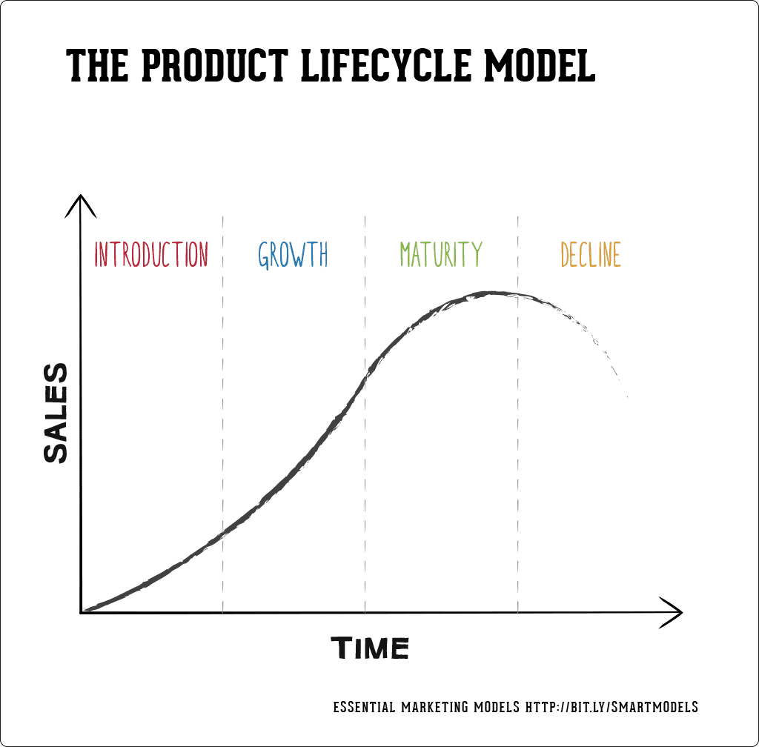

If you're looking for a marketing planning framework to reach and acquire more customers, why not book a free consultation to kick off your strategic planning? Identify your problems, and discuss solutions that work for your business. Find out more about the RACE Framework, and integrated marketing strategy tools covered in this blog. Book in your call to get started today.

**Introduction**

Product marketing managers must introduce their new product while it's relatively unknown and production is small. The price is often higher as distribution is limited and promotion is personalized. At this point, it is worth returning to the infamous statistic that [95% of new products fail](https://www.inc.com/marc-emmer/95-percent-of-new-products-fail-here-are-6-steps-to-make-sure-yours-dont.html). So planning is key. We recommend planning your new product launch using the RACE planning framework.

Our marketing solutions for Business Members helps define the types of communications, best practices and optimization techniques across the RACE planning framework that maximize your customers' and products' lifetime values.

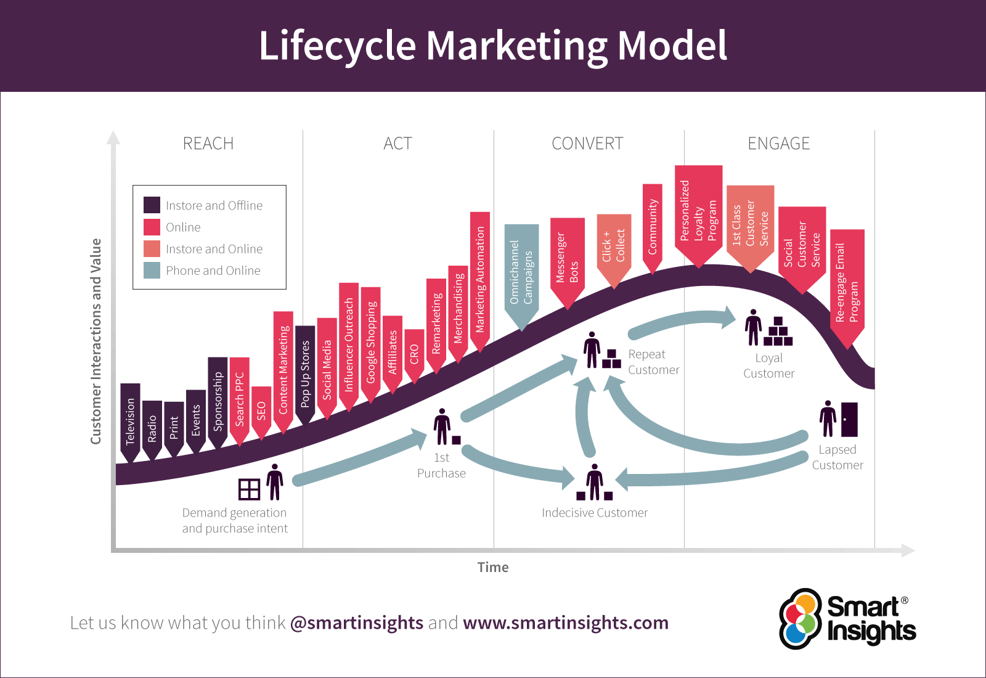

**Growth**

Congratulations - popularity for your product is growing! As your market share increases, now is the time to focus your RACE objectives on market penetration and development -  such as communicating product benefits and building the brand.

Since your product is being bought in greater numbers and, with volume, the price is declining and profits increase. When upscaling any business, bear in mind the practical implications for resource, sumarized by Lilach Bullock in her blog blog 4 essential elements of a scalable business:

Scale too quickly and you can suffer from not being prepared. Scale slowly or unevenly and you may get stuck with employees you hired that you don’t need anymore. Overall, you need to ensure that the rate of your growth doesn’t hurt you in the long run.

We've got hundreds of marketing tools and templates designed to grow your business. Book a free consultation call to talk through your opportunities using the RACE Framework, so you can make an informed decision about the best strategy for your business. Book your call to find out more.

**Maturity**

The product competes with alternatives and its pricing drops. Distribution becomes intense (it’s available everywhere) and promotion focuses on the differences to competitors’ products.

When managing differentiation strategy, [DRIP is another marketing model featured in our essential marketing models guide](https://www.smartinsights.com/guides/essential-marketing-models/). DRIP is an acronym for differentiate, reinforce, inform and persuade.

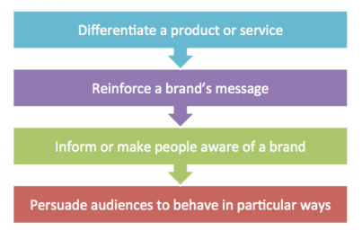

**Decline**

Reaching the end of its life, the product faces fewer competitors. The price may rise and distribution has become selective as some distributors have dropped the product. Promotion aims to remind customers of its existence.

In our free, illustrated guide to 15 classic planning models diagrams we explain what they are and give examples of why and how to apply them in business.

**How can I use this marketing model?**

When reviewing your business you need to understand which stage your products or services have reached across your portfolio of all products which can be assessed in terms of market share and growth using the [BCG matrix model](https://www.smartinsights.com/marketing-planning/marketing-models/use-bcg-matrix/). Reviewing the product of portfolio enables marketers to plan for new products, reinvent existing products or discontinue products that are in serious decline.

You can also relate digital marketing products and services to the popular diffusion of innovation model [hype cycles](https://www.smartinsights.com/managing-digital-marketing/marketing-innovation/technology-for-innovation-in-marketing/).

**An example of the Product Life Cycle model**

This example shows how the yoghurt product category has moved through the product life cycle by remixing elements of the marketing mix. Examples of stages and how PLC evolved are:

**Introduction**

* Yoghurt available in health food stores
* Functional and plain packaging
* Promoted as a health food

**Growth**

* Yoghurt available in supermarket chiller cabinets
* Packaging gets a makeover
* New flavours introduced (e.g. strawberry and vanilla)

**Maturity**

* Product re-invented with added fruit/muesli/chocolate
* Packaging changes into different shapes and sizes
* Promoted as a fun snack or luxury treat

**Decline**

* Not yet!

**How to extend the Product Life Cycle**

There are several strategies you can use to attempt to extend the life cycle of your product and stave off decline without radically changing your product.

**Advertising/packaging**

The structure of your advertising and physical appearance of your product should always be considered. Who is it targeting? How do you refer to the product? Tweaking your messages and packaging and aiming them at different demographics can reinvigorate your product or brand. One of the best examples of this is Dollar Shave Club’s video ad that presented its grooming product delivery service in a new, humorous light. To date, the video has nearly 30 million views and sparked 12,000 orders in the two days following their video being posted.

**Price/specification**

You can also assess your product features and the price point they’re being offered at. You can then choose to either lower your price for the same product, in an attempt to prolong its appeal by increasing its sense of value, or you can add new features the product to re-energize its place in your industry. A common example of this is the many iterations of laptops you see released by a brand. Large changes are marked by new product names (e.g. Lenovo YOGA laptops) while spec upgrades are labelled ‘generations’. The more generations of a product, the cheaper older generations become as they are seen as ‘value’ options.

A tip is to review customer feedback continuously, to ensure your products don’t reach the end of their shelf life, carry out regular customer surveys. Get feedback and find out what works, what doesn’t and why.

**New markets/platforms**

To maximize your product’s longevity, you should always explore possibilities of launching your product in new markets or on new platforms. Netflix transformed itself from a DVD delivery service into one of the largest video streaming platforms in the world. Launching its streaming service in the US in 2007, it started to expand into other markets with Canada in 2010, then South American countries such as Brazil, Argentina, and Paraguay. Popularity continued to grow, and Netflix expanded into Europe in 2012. Today they boast [167 million subscribers](https://www.comparitech.com/blog/vpn-privacy/netflix-statistics-facts-figures/).

As technology evolves, so do the platforms you have available for your products. If you find ways for your products to remain flexible in their distribution, you can prolong their life-cycle for years.

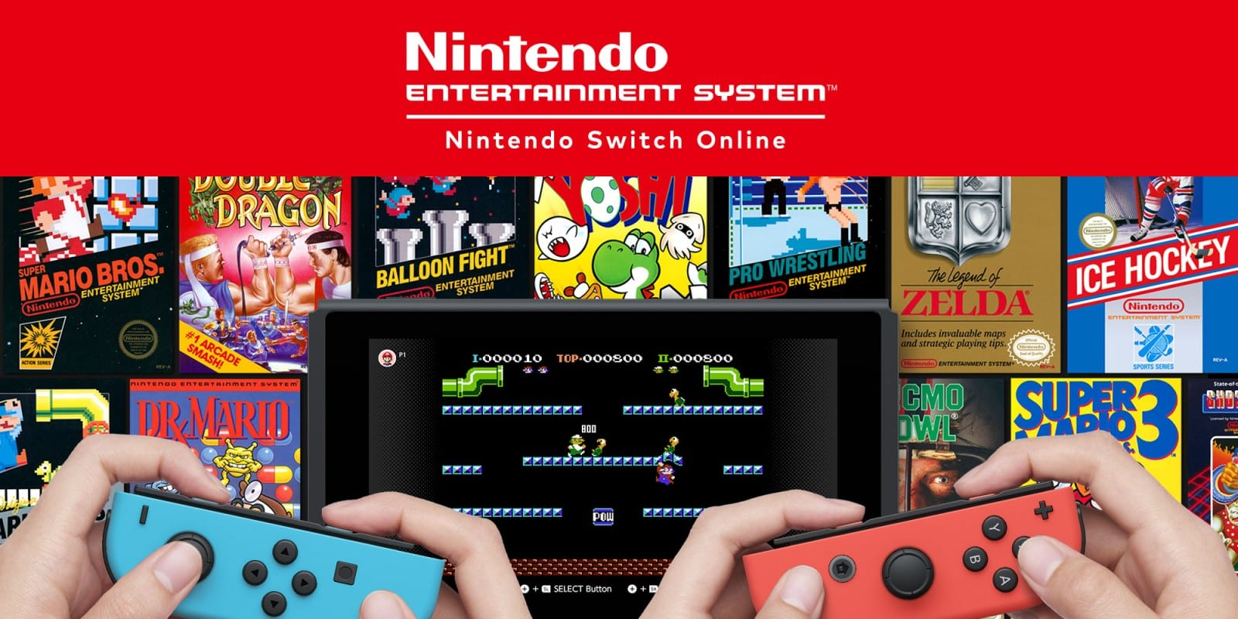

Nintendo has been at the forefront of extending the lifespan of their games by continuously utilizing the changing platforms and technology available to them. Several games originally launched in the 1980s and available on cartridges have been re-released multiple times to extend their lifespan:

* Early-2000s: Games released on GameBoy Advance, with the new appeal of portability (akin to portable music devices like Walkman)
* Late-2000s: Games released on the Wii Virtual Console, with the new appeal of forming a non-physical collection on one device (akin to the rise of digital downloads of films)
* 2010s: These games have now been made available on their Switch console as a subscription product (akin to Netflix and other on-demand services)
* 2019 saw the release of the Nintendo Switch Lite: This slinkier, lighter device won't hook up to your TV but it does offer the convenience of handheld on-the-go  gaming.