[9 Benefits of Business Process Management (BPM)](https://www.process.st/benefits-of-bpm-business-process-management/)

[Adam Henshall](https://www.process.st/author/adamh/), August 5, 2019

The world of business is changing fast and there’s no time for hesitation.

In every domain, competition is getting strong and the market is getting less tolerant of mistakes. This is why more and more companies worldwide are embracing Business Process Management (BPM).

BPM is a management system which aims at improving a company’s overall performance through optimization of important business processes, appropriate management, and maintaining those changes which have been made.

The BPM market is expected to grow to approximately USD $16 billion by 2023, with a 14% CAGR between 2017 and 2023 ([Business Process Management Market Research Report](https://www.marketresearchfuture.com/reports/business-process-management-market-3408)).

This shows that companies on a global level have recognized the need for improvement, development, and change.

Can business process management help your organization achieve its goals? It’s time to take a deeper look. Here is an exploration of the main benefits of adopting BPM and the reason why the BPM market is thriving worldwide.

Every business’s operations contain a set of processes that are repeated over and over again. These processes make up the core of that business.

Within each business, every business area either works with information or materials, sometimes both. That data or materials is transformed. For example, raw materials may be manufactured into a sellable good. Data may be transformed into a report. Every business area could possibly be responsible for a significant number of processes.

Business process management analyzes each of these processes.

It looks at them individually, and it involves analyzing how the different processes impact one another. The idea is to get good insights into the current state of these processes first. The next step is to identify where these processes can be improved.

The ultimate goal is to make the organization more efficient and effective.

It’s important to understand that business process management is not task management. Tasks are project related. Business processes relate to the core operations of a business.

However, projects are often the result of business process management. For example, business process management could identify redundancies in the order placing process at an online retailer. That could lead to a project that involves researching and selecting a new software package. That project would be divided into a series of tasks.

## The 9 benefits of BPM: How to boost your business!



### 1. Business Process Management can help businesses reduce costs

In a 2018 survey by [RedHat](https://www.bptrends.com/bpt/wp-content/uploads/2018-BPM-Survey.pdf), more than 50 percent of participants recognized saving money as the main reason for adopting BPM. Companies need to focus on reducing costs in order to stay functional and steady.

You can [reduce labor and operational costs](https://www.tomedes.com/translator-hub/business-process-outsourcing-advantages) by adopting business process outsourcing. The benefit of business process outsourcing is that it enables you to turn fixed labor costs into variable labor costs. You will be able to save because you only have to pay for the service that you need.

Other advantages of BPO include focused work, expertise, fewer equipment costs, and efficiency. Since you are hiring employees with a specific skill set to do specific tasks, the employees are focused on those tasks. If they have already been doing similar work for a while, then it means that they are already experts at their fields. Since you are outsourcing workers, you will be able to save on equipment costs because they will be using their own equipment. Since they are using their own equipment then they are already familiar with the hardware and software and will thus be more efficient at their jobs.

It’s important to remember that business process management begins with understanding. In many cases, that means identifying each business process. Then you can put those basic steps in action and begin to see how they operate in the wild.

Next, those processes are mapped in detail. These process maps provide great insights such as the duration, resources needed, frequency, and costs involved. These steps must often be coordinated between multiple teams, as an organization’s most important processes often touch one or more business area.

Once this mapping process is complete, it’s much easier to identify where costs can be reduced. This could be achieved by eliminating redundancies, identifying quality control issues, and highlighting excessive materials and labor costs. Of course, cost reduction is just one benefit of this process.

Business process management can also help organizations to find processes that are simply not worth the time and investment. These processes can sometimes be eliminated. In other cases, they can be outsourced. For example, a multinational corporation might determine that it’s better to outsource localization tasks.

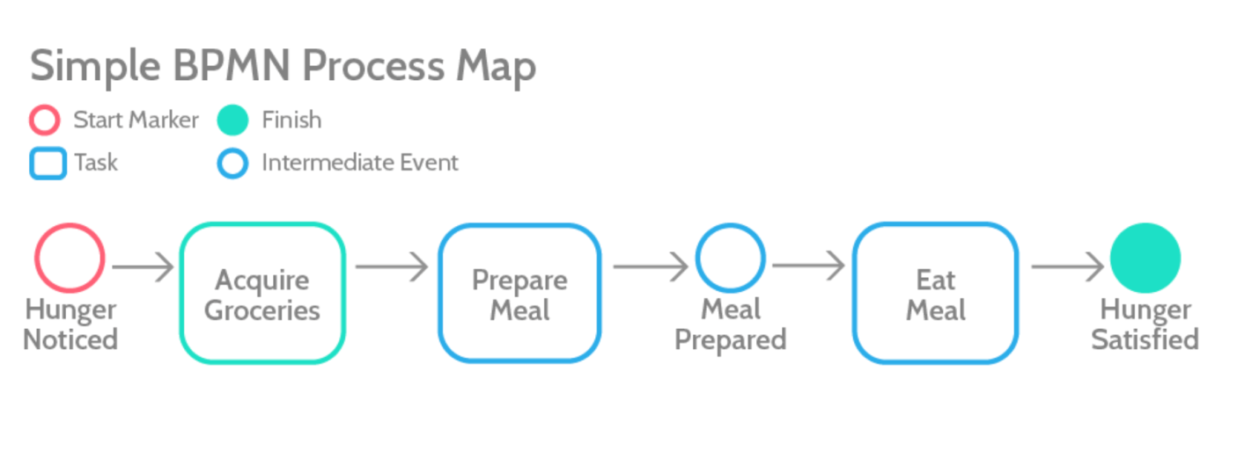

Dwight Mackey, an account manager at [The Word Point](https://thewordpoint.com/), mentions this as a motivating factor in corporations hiring localization services. He says:

“In order for businesses to succeed, they must be able to react to changing economic times. That means identifying the processes that are mission critical, and that should stay in house. By outsourcing other processes, they remain lean and agile. It’s much less expensive in terms of direct costs and resources to contract work like this out to other vendors.”

### 2. Business Process Management can help businesses recognize and respond to new customer demands

Successful businesses must be responsive. They must be able to recognize changing customer demands and preferences and react quickly. This is another area where a successful BPM strategy can really help. It forces decision-makers to pay attention.

One of the more recent shifts in the way we view process management is that processes themselves are becoming more [customer-focused](https://www.heflo.com/blog/bpm/customer-centric-processes/) and less centered around productivity. Rather than asking how to improve processes in order to get a product out quickly and more efficiently, stakeholders now want to improve processes to better meet the customer’s needs.

This has a direct impact on metrics such as customer satisfaction and retention. Further, modifying business processes so that they meet customers’ needs often leads to other important improvements that lead to better productivity and efficiency.

[Business process management software](https://www.process.st/bpm-software/) like [Process Street](https://www.capterra.com/p/135004/Process-Street/) can be used as a tool for modeling new process ideas that are centered around the customer. These can then be implemented in situations. A good business process management solution will allow companies to test changes before implementing them in production situations

By focusing on the needs of the customers, business managers can identify changing trends in customer needs and preferences. Here are some other benefits to changing processes so that they are customer-centered:

* Meeting customer needs often leads indirectly to improved productivity.
* Processes become more flexible to help meet changing needs.
* It encourages a solution-based approach.
* Processes can be re-engineered with a new or additional goal of improving customer experiences.
* Innovation is encouraged.
* [BPM software](https://solutionsreview.com/business-process-management/top-5-bpm-software-solutions-to-help-upgrade-your-business/) allows you to make changes quickly with built-in quality controls.

### 3. Companies are increasingly finding that their old business models are no longer effective

If your company has been working according to an outdated business model, you won’t get very far. It’s time to make changes today, not at some point in the future. You simply cannot ignore the changes happening around you.

Technology, people, customers’ habits, changing socioeconomic conditions all contribute to a rapidly changing landscape. If you fail to make the right changes at the right time, it’s virtually guaranteed that your competitors are going to outdo you at every turn.

Business process management helps you to understand your current processes, and create new ones. In fact, a [report from Gartner](https://www.gartner.com/smarterwithgartner/bpm-is-critical-to-business-transformation-success/) details how BPM can help ensure that business transformation happens successfully. One of the details in the report is that businesses making changes must identify new business outcomes.

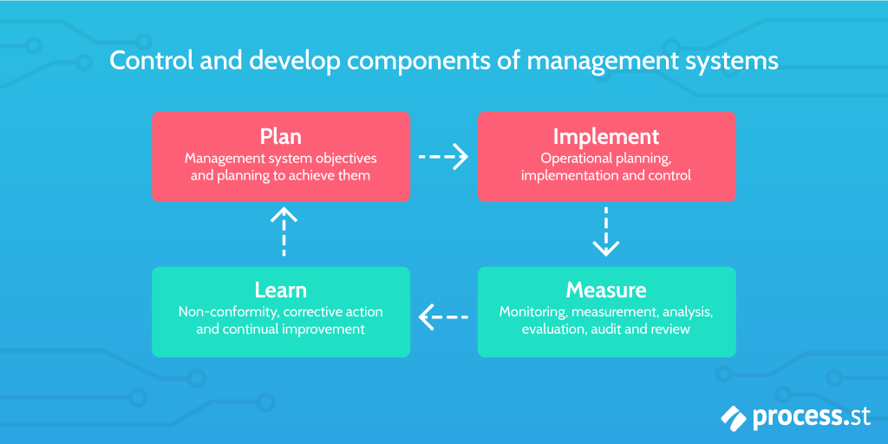

Here are some other important takeaways:

* An effective BPM solution will help business owners identify the processes they need to include in order to get the outcomes they need.
* It’s important to identify where a business is in terms of business process management, not just overall, but for each upcoming project. Whether or not a project succeeds can be dependent upon whether or not an effective [BPM solution](http://www.q3edge.com/best-bpm-tools-available/) is already in place.
* Weaknesses must be identified so that changes can be made to ensure that the organization has the capabilities it needs moving forward.

4. Business Process Management can lead to increased productivity

With rising competition and more demanding survival conditions, companies must work at their best.

BPM can help increase productivity, and enable companies to give customers more. One example of this is Adidas which went through a major [process overhaul](https://www.itweb.co.za/content/LPp6V7r1jO3vDKQz). This resulted in the realization of several organizational goals, one of which was improved productivity. Specifically, they were able to reduce the lag time between order placement, and visibility of orders in the system. This led to orders being filled faster and more efficiently.

All of this was thanks to the kind of objective analysis that good business process management brings about. Without business process management, the company likely wouldn’t have recognized that inefficiency

### 5. Companies that use Business Process Management have a better chance at remaining competitive

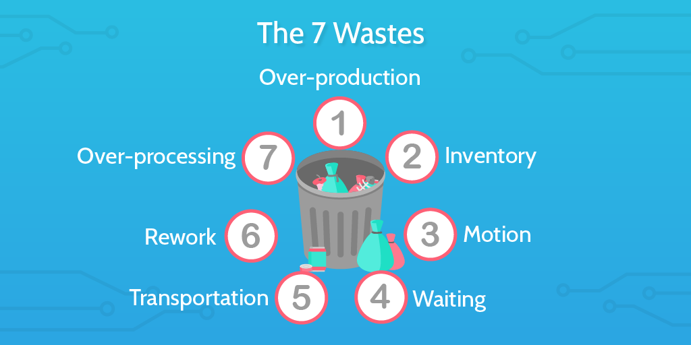

If a company cannot keep up with their competitors, they will find themselves quickly brushed aside.

That can lead to a downfall.

When your processes are repetitive and inefficient they become filled with waste, which means you don’t have time to focus on research and development, or other steps that make your company better able to stave off the competition. This is because without streamlining your business processes, your focus will always be operational; that limits innovation and allows waste to accumulate, further slowing you down.

When business processes are reliable and efficient, your business will have more resources to dedicate to growth and development.

### 6. Business Process Management makes it easier to retain customers

It’s difficult enough to gain new customers. Retaining them can be even more of a challenge.

However, retaining customers has a much bigger ROI than converting new ones. It costs less to do so, and existing customers offer more profit over time.

When you improve metrics such as productivity and innovation, your customers are more likely to be satisfied with your business. This leads to improved retention. If you can align your use of BPM to create better customer experiences then you’ll reap the rewards.

This is important because [67% of customers](https://www.huffpost.com/entry/50-important-customer-exp_b_8295772) state that poor experience is their key reason for dropping a product or service.

You can build on that even further by tying your customer support, success, and service provisions into the rest of your company activities via an integrated BPM approach.

By having a process for everything and recording the data from each, the reactive and proactive teams can work together to identify opportunities and learn from each others’ interactions with customers.

### 7. You can standardize your processes with BPM

It is important for a company to have a clear, strategic plan of how things are done. BPM helps you to [standardize the processes](https://www.process.st/process-standardization/) within your company. When processes are not standardized, quality control among other things becomes difficult.

Here are some other benefits that you can realize by using process management to standardize the way things are done across your organization:

* Once processes have been standardized, it becomes easier to improve them in the future. Processes are documented in the standardization process. You can also standardize processes, then take on business process improvement initiatives (BPI) in phases.
* Standardized processes lead to better productivity and increased output. When you standardize, you identify the best methodologies to use. Then put that into place. That can then be propagated across the organization.
* Onboarding is much easier with standardization. New hires can all be taught the same thing. Imagine employee transfers and other lateral moves as well. When operational processes are standardized, there’s significantly less need to retrain employees in new methods.
* When you have standardized processes, you can begin to schedule those processes to run at the times you know they’ll be needed. Standardizing processes helps you understand and pre-empt the actions of your own business.

### 8. Business Process Management leads to cross-department collaboration

Everyone in a company needs to be on the same page, working together towards a common set of goals.

BPM helps improve cross-department collaboration which brings immense benefits to the company. Without business process management, different business areas may be entirely unaware of how their processes relate to or conflict with one another.

This happens in two ways.

First, during the process mapping and standardization phase, different business areas and teams must communicate with one another. They must identify processes that are shared, determine where redundancies exist, and learn where shared information and expertise may be beneficial.

Next, this collaboration is fostered moving forward as the strategies created through business process management continue to be implemented.

### 9. Business Process Management improves safety, security, and compliance

All too often, issues with safety, security, and compliance arise from a lack of transparency.

An important task controlled by one business area, for example, doesn’t get the oversight it should. Later, it’s revealed that the processes in place to complete that task are in violation of compliance standards, or perhaps unsafe. As a result, the company could find itself afoul of laws or standards set by various governmental organizations or licensing bodies.

By using a comprehensive BPM plan, these processes no longer remain in the dark.

Instead, stakeholders are made aware of compliance issues, are better able to stay up to date regarding any changes, and can ensure that all processes meet safety, compliance, and security standards both internal and external.

This can help to reduce liability and safety concerns significantly

