**Business Process Management- A helpful guide for every organization**

 Philip Gao , 15-5-2020

One of the biggest challenges for teams is to manage the business process. Business Process Management (BPM) denotes a way how an organization creates predictable processes, edits them, or analyzes them. Your company has a number of departments taking data and converting it into some forms. Every department is responsible for managing different processes. Besides, your company needs to take the best step for looking at these processes. It identifies the present state and finds out areas that need improvement.

**No BPM? You can never trace out mistakes**

Everybody learns from mistakes. However, to learn something and avoid a mess-up, you have to find out what is wrong. In other words, you must know what you have done in the wrong way. It will prevent you from repeated mistakes in your business. In the corporate world, you have to follow a process, and make where we are in an overall process. Your team aims to rely on processes. For instance, you have sent emails with a broken link. In this situation, you have to check for broken links. You will also provide you with a guide for business process management, and you will know the way of managing your present processes. You can develop an inventory of different processes documents and optimize the existing processes to prevent disasters.

**Business Process Management and Normalization of Deviance**

From the report of Powering Productivity, you have learned that wrong processes can result in the inefficiency of a company. Lots of big organizations are facing challenges for their complicated procedures, and they ultimately find lower performance standards.

However, internal issues of a company may also affect the process management. There can be corruption without sending you any warning. You call it the normalization of deviance. Diane Vaughan, an American sociologist, developed the concept- Normalization of deviance. Vaughan has created the theory while checking different mistakes, disasters, and conflicts. She thinks that the real source of Normalization of deviance is in the related environment. According to Vaughan, the major organizational factors include moments that result in disasters.

Social Normalization of deviance indicates everyone in an organization is familiar with some deviant behaviors. This organization does not think it to be a deviant, although it has gone beyond its rule for safety.

Effective business process management isn’t merely about organizing people. This management process is also about the analysis of processes. On a regular level, processes have to work appropriately by presenting detailed steps to assume a range of tasks. But, high-level processes map out activities of the broader company, and they line up with the company’s strategy and direction. Optimization of processes and analysis of every step enables you to make out mistakes.

To implement the best business process management systems, you have to ensure that this is one of the collaborative setups. AIIM thinks that business process management must involve every team member. Everyone has to feel his control of the processes employed for business management. Besides, these processes have to input from each of the members to make the process more effective.Although the Normalization of deviance is one of the social processes, you may apply your own efforts for normalizing deviance. However, in an organization, others will review your work and identify your flaws.

**Normalization of deviance- How you manage it**

You can look for the best tools for the business process management, and with the use of these tools, you may make the essential changes. It becomes easy for you to identify comprehensive business processes and find the root of issues. You may make different processes for your employees. Then, you can optimize those processes with iterative improvements.Moreover, you can easily collect data on the way of conducting your processes. Thus, with the use of the best BPM tools, you can make your optimization technique highly effective and accomplish complicated tasks. Also, you can reduce mistakes and make the quality better. Lots of companies are facing the problem, like Normalization of deviance. However, the good news for you is that it is manageable with the right steps.

BPM is not a one-time activity, and it questions the current operational status. You have to manage processes to keep them updated and tested. As business is never stable and your company size can change quickly, processes may turn out to be outdated. Simultaneously, you need to use the latest tools to deal with these procedures. Properly optimized business processes help in saving time and resources. If those procedures are wrong, and they continue for years, then you can find an effect on revenue.We have already mentioned that ownership is one of the important factors related to BPM. Your team members, owning the BPM, have to be responsible for optimizing them. Instead of keeping your business procedures hidden, you have to let others use them and get feedback. Wade Foster of Zapier is one of the professionals talking about business procedures. He enables everyone to edit his business procedures and promote openness as the culture of his company.

**Optimization of business procedures**

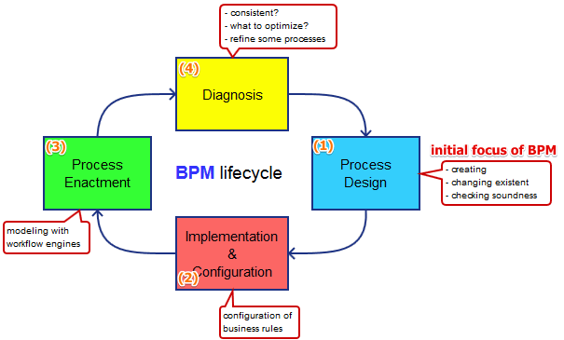

You may use a tool to deal with simple processes. However, for longer procedures involve several team members, you have to think deeper. Your first task is to find answers to some questions

* What goal do you have behind your business procedures?
* When have you started the process?
* Which department of your company is dealing with your business process?
* What data are you transferring between different steps?

If you have not optimized your processes, then you will find conflict among employees. Thus, it is better to employ a team that knows the way of creating, marketing, distributing, selling, and managing everything.Constant optimization is essential for your business processes. You may apply different techniques to manage them and identify the right KPI for refinement.

**Automation to manage business processes**

You can find a myth that process management never equals to process automation. Truly, automated processes ensure high efficiency. Still, you can skip these processes while you can accomplish the task better in a manual way. In some cases, the common sense of human beings is needed to correct errors.All businesses employ some types of systems. We can define the process as something that produces output after taking input. Your business process can be about internal staffing, revenue-producing, invoicing, and other activities. Most of these processes are manageable with automation techniques.Business process automation is one of the trends emerging in the present corporate world to deal with a variety of tasks without manual input. Lots of companies have asked their IT departments to rely on automated technologies to reduce operational costs. Surely, they will have limitless benefits from this automation.

Now, you may raise a question- Is automation the right choice for your business process. You can choose automated systems when

* You have to deal with repetitive processes.
* Your processes do not need human intervention and logical thinking at any time.
* They need high consistency.
* They have to be free of errors.

We can say that automation is one of the parts of BPM. You must focus on several activities related to BPM. Besides, BPM relates to everything, ranging from conceptualization to implementation. It also means separate or simultaneous control of business processes.

**Business process automation- Know the major principles**

* Understand your business processes and analyze them thoroughly. After doing it, you can simplify them to introduce automation.
* Automated processes must remain integrated with other processes for smoother operation.
* The automated business processes should have consistency and correspond to other procedures.
* Based on resources and funds, you may categorize your tasks. The target of automation is to reduce complications, and you have to focus on this fact.
* You can train your staff to know the workflow and learn the way of dealing with digital documents.
* ZZenTao- Making the management process easier

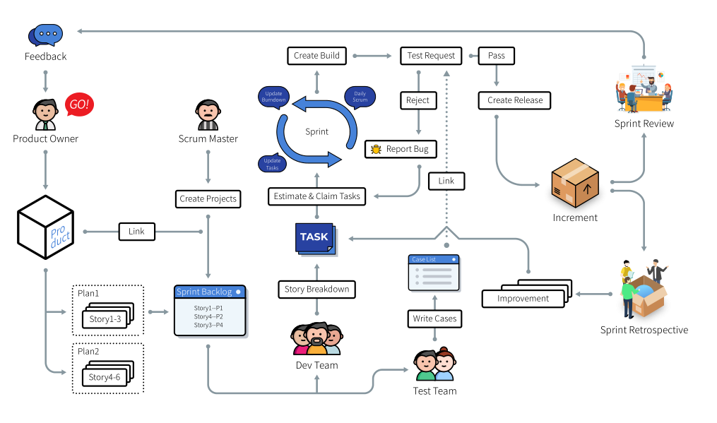

While talking about Business Process Management, you need to know there is one of the reliable tools, Zentao. This open-source tool helps in managing projects, products, bugs, documents, and to-do lists.

It is a pragmatic and practical solution with lots of features and user-friendly interfaces. Statistical reports, comprehensive API, and easy-to-use search features of the tool are highly useful. You may also use ZenTao Cloud to avoid installation process and maintenance. It is the best option for multi-regional teams that need to have access to your services. Moreover, Zentao ensures faster work management and bug resolutions. You can collaborate with your team by using this software.

Now, we can conclude that you may use the best automation tool to manage your business processes. Automation is the right option for small and medium organizations that have a lack of human power to accomplish tasks. Moreover, automation will help in increasing the profitability of a business. However, your employees must know the steps to embrace the new technology.