CASE STUDY – 01

**Case Study #1: CrazyEgg**

[CrazyEgg](http://crazyegg.com/) is a SaaS company that provides a heat map tool to help businesses better understand how users are interacting with their site.

Their [sales funnel](http://www.pardot.com/lead-nurturing/breaking-3-stages-sales-funnel/) breaks down in the following five stages:

**1) Awareness**

Building awareness is the first step of any funnel. Before readers can be guided down the process to make a purchase, they first have to find out about your business in some way and become interested in what you have to offer. Marketing at this stage involves paid traffic, blog content, and optimizing for SEO to get more exposure for their brand.

Here’s one of CrazyEgg’s Facebook ads that was used to build awareness:

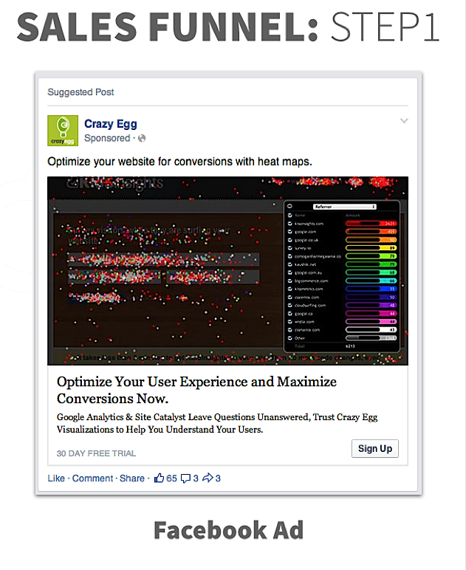

Here’s another example of content that was used to build awareness:

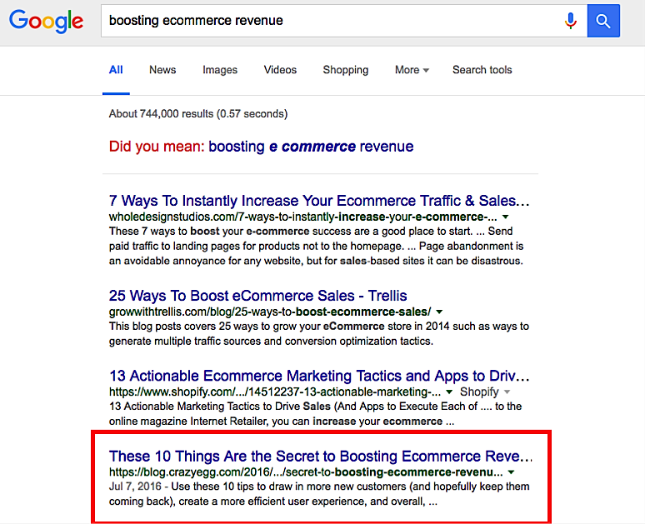

For readers who want to know how to boost e-commerce revenue, they'll find one of CrazyEgg’s blog posts on the first page of Google's search results.

Readers will have different experiences going through CrazyEgg’s funnel depending on what content they see first. In this example, we’ll stick with what follows after clicking on the Facebook ad.

**2) Interest**

The second step in CrazyEgg’s funnel is directing readers to their home page. From there, prospects have the option to express further interest in the business by entering their website’s URL to see a heatmap analysis of why their visitors are leaving.

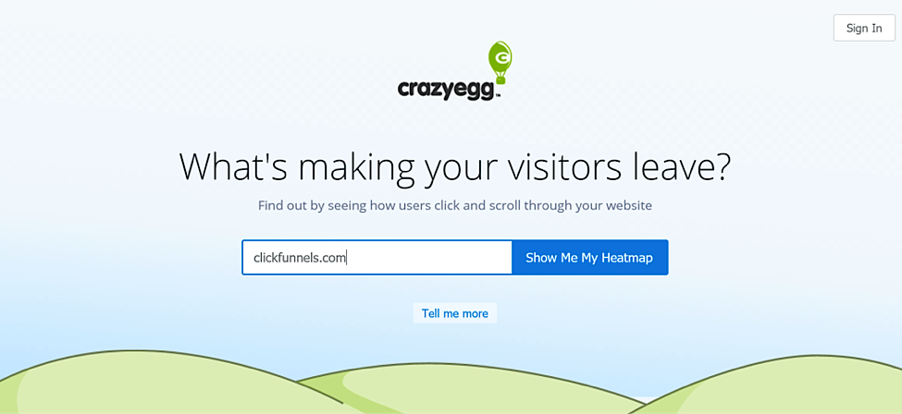

**3) Decision**

Once prospects enter their website URL into the box on CrazyEgg’s home page, they are taken to a page that requests access to their Google Analytics account. After they've provided access, they’re taken to the following pricing page, where they’re asked to choose between a few pricing plans.

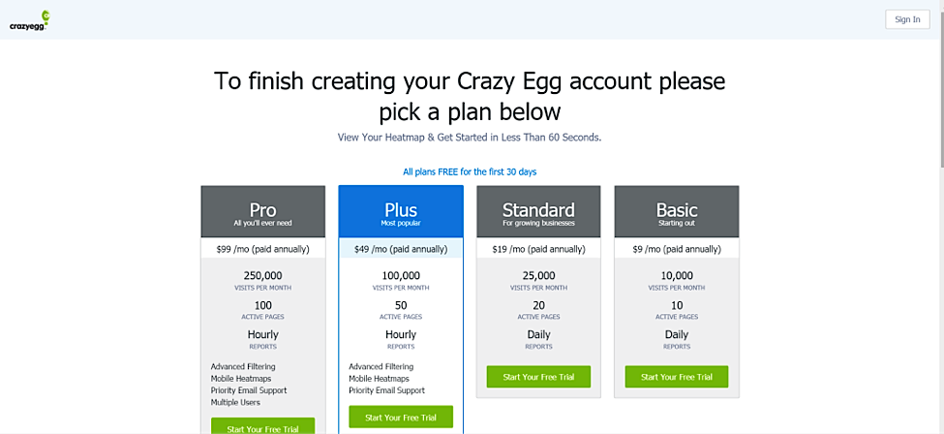

Leads can either choose one of the options right away, or they can bounce, in which case CrazyEgg sends them a lead nurturing autoresponder sequence over a span of time.

For example, according to Clickfunnels, CrazyEgg builds a relationship over time with their audience by sending out “How can I help you” e-mails and educational e-mails to give leads more information about the product and the company.

**4) Sale**

Finally, when leads are ready to buy, they’re directed to the following page where they’re prompted to fill out their billing information. This page includes logos of popular brands that use CrazyEgg, as well as a list of common questions (it’s no secret that FAQs can grow your sales).

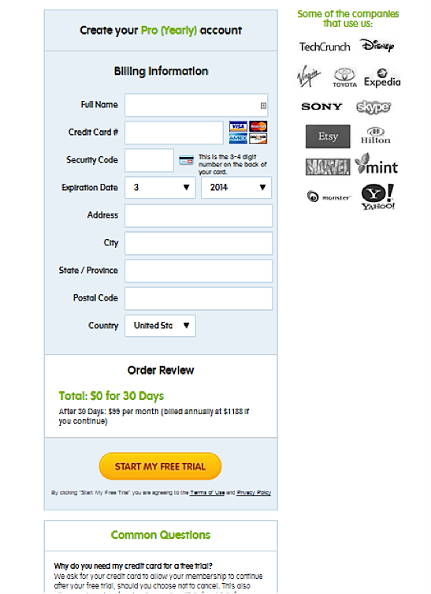

Questions –

1. Why do you think that this Funnel works? Justify with atleast 3 reasons.