Critical HR, Benefits, and Payroll Compliance Information for 2021

Remote work is here to stay. Paid leave programs are expanding. Healthcare costs are rising. Here’s a rundown of next year’s biggest HR trends.

*Stay on top of HR compliance in 2021 with these emerging workplace trends*

In 2020, the employment space experienced unprecedented changes, many arising from the COVID-19 pandemic. Now as we venture into 2021, more pivots await. To help you prepare, we’ve rounded up human resources, benefits, and payroll compliance trends to look out for in 2021.

Specifically:

* Remote work
* Healthcare
* Minimum wage
* Paid leave
* HSAs, HRAs, and FSAs
* Predictive scheduling
* State EEO reporting
* Payroll taxes
* HR/payroll automation

Remote work expected to surge

Remote work in the United States rose 159% between 2005 and 2017, according to a 2019 [analysis](https://www.prweb.com/releases/global_workplace_analytics_flexjobs_report_159_percent_increase_in_remote_work_since_2005/prweb16471457.htm#:~:text=New%20analysis%20finds%20strong%20continued%20growth%20in%20telecommuting%20among%20U.S.%20workers&text=Based%20on%20an%20analysis%20of,percent%20between%202005%20and%202017.). The COVID-19 pandemic has only expedited this growth.

In April 2020, Brookings Institution said that since COVID-19 began, up to half of U.S. employees are [working from home](https://www.brookings.edu/blog/up-front/2020/04/06/telecommuting-will-likely-continue-long-after-the-pandemic/) — more than twice the amount who worked from home between 2017 and 2018. Though many remote workers have since returned to their onsite locations, remote work is expected to continue its monumental climb.

In a [forecast](https://globalworkplaceanalytics.com/work-at-home-after-covid-19-our-forecast) Workplace Global Analytics says, “those who were working remotely before the pandemic, will increase their frequency after they are allowed to return to their offices. For those who were new to remote work until the pandemic, we believe there will be a significant upswing in their adoption.” The forecast estimates that by the end of 2021, we will see 25-30% of U.S. employees working from home multiple days per week.

If you have remote workers — or are planning to make this transition in 2021 — make sure your remote-work policies, procedures, and practices are airtight. Examine:

* Discrimination risks, such as during hiring and performance management
* [Timekeeping rules and best practices](https://www.zenefits.com/workest/timekeeping-best-practices-for-your-remote-team/)
* Federal, state, and local wage/hour laws
* Paid and unpaid time off, whether mandatory or voluntary
* Federal and applicable state/local tax withholding laws
* Data privacy and security risks
* Health and safety, including workers’ compensation
* Employee discipline and termination

[](https://www.zenefits.com/workest/inbound/uno8one)

Healthcare costs projected to rise

In a 2020 survey by Mercer, employers predict their [healthcare costs](https://www.mercer.us/our-thinking/healthcare/health-benefit-costs-expected-to-grow-4-point-4-percent-in-2021-mercer-survey-finds.html) for 2021 will increase (on average) 4.4% — a fairly “normal” jump, they say. Per Mercer, this increase is only a bit higher than the moderate cost growth they’ve observed over the last 6 years.

In a more targeted survey (involving large employers), the Business Group on Health [forecasts](https://www.businessgrouphealth.org/en/who-we-are/newsroom/press-releases/large-us-employers-accelerating-adoption-of-virtual-care-mental-health-services-for-2021#:~:text=According%20to%20the%202021%20Large,of%20the%20last%20five%20years.) that employer healthcare costs for 2021 will increase 5.3% — up from 5% projected over the last 5 years. The total per-employee cost for 2021 is estimated at $15,500, increasing from $14,769 in 2020. As in recent years, employers are expected to cover 70% of healthcare costs while employees shoulder the remaining 30%.

Next are [projected](https://www.segalco.com/consulting-insights/medical-cost-trend-2021) per-person cost increases based on plan type.

[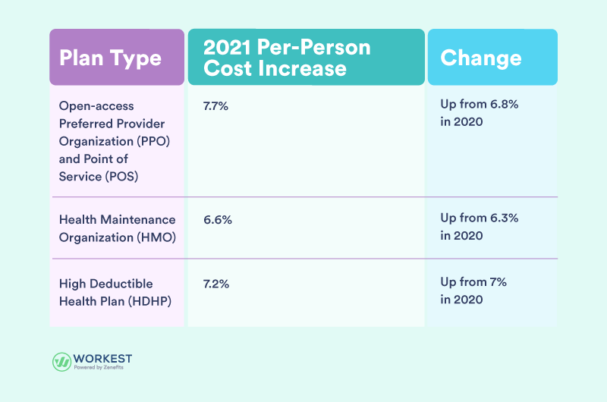](https://www.zenefits.com/workest/?attachment_id=13070)Data source: The Segal Group.

Despite the various projected increases, most employers (57%) in the Mercer survey say they “will make no changes whatsoever to reduce cost in their medical plans in 2021.”

Considerations when setting cost-sharing amounts for 2021

* The Affordable Care Act’s [“affordability” percentage](https://www.zenefits.com/workest/aca-affordability-threshold-for-2021-what-ales-need-to-know/), which rises to 9.83% in 2021, up from 9.78% in 2020. Basically, if you’re an Applicable Large Employer (ALE), you cannot charge more than 9.83% (of the employee’s household income) for the lowest-cost self-only plan.
* Mental health parity laws, including the federal [Mental Health Parity and Addiction Equity Act (MHPAEA) of 2008](https://www.cms.gov/CCIIO/Programs-and-Initiatives/Other-Insurance-Protections/mhpaea_factsheet#:~:text=The%20Paul%20Wellstone%20and%20Pete,favorable%20benefit%20limitations%20on%20those). If you have more than 50 employees and a group health plan that includes mental health coverage, you must comply with the MHPAEA. Under the MHPAEA, the plan cannot offer less generous benefits/services for mental health than for physical health. Some states, as well, have established mental health parity laws.

State minimum wage accelerates

While advocates [continue to push](https://www.epi.org/publication/why-america-needs-a-15-minimum-wage/) for a higher federal minimum wage (which currently stands at $7.25 per hour), states are hiking their own. See the table below for state minimum wage increases in 2021.

| State | 2021 (increased) minimum wage |
| --- | --- |
| Alaska | $10.34 |
| Arizona | $12.15 |
| Arkansas | $11 |
| California | $13 (employers with 25 or fewer employees); $14 (employers with 26 or more employees) |
| Colorado | $12.32 |
| Connecticut | $13 |
| Delaware | $10.21 |
| Florida | $10 |
| Illinois | $11 |
| Maine | $12.15 |

**State minimum wage considerations:**

* Not all increases will take effect January 1, 2021. For instance, Connecticut’s minimum wage will increase August 1, 2021
* Some cities and counties have their own minimum wage laws, and may have increases in 2021 — such as San Diego (California) and Denver (Colorado)
* Minimum wage increases for tipped employees vary by jurisdiction

**Paid leave expansions**

The [paid-leave phenomenon](https://research.upjohn.org/cgi/viewcontent.cgi?article=1283&context=up_workingpapers) has been soaring in recent years. So, it’s no surprise that paid leave landed in Mercer’s [“Top 10 compliance issues for health and leave benefits in 2021.”](https://www.mercer.com/content/dam/mercer/attachments/global/law-and-policy/gl-2020-top-10-compliance-issues-for-health-and-leave-benefits-in-2021.pdf)

**Mercer recommends that employers:**

* Review their paid sick, vacation, disability, and family/parental leave programs
* Compare existing paid leave policies with those required by federal, state, or local law — including any COVID-19 paid leave mandates that spill over into 2021
* Adjust paid leave programs and policies as needed.
* Monitor paid leave regulations. For instance, Connecticut’s paid family and medical leave program starts January 1, 2021

**HSA, HRA, and FSA developments**

Joining paid leave on Mercer’s top 10 compliance list are health savings accounts (HSAs), health reimbursement arrangements (HRAs), and flexible spending accounts (FSAs).

**If you offer an HSA, HRA, or FSA, be sure to:**

* Comply with the HSA and FSA contributions limits for 2021
* Identify [mandatory and optional COVID-19 relief](https://www.zenefits.com/workest/hsa-fsa-and-hra-relief-under-the-cares-act/)
* Incorporate newly-eligible HSA, HRA, and FSA expenses — such as over-the-counter medicines and menstrual care products authorized by the CARES Act
* Evaluate plan designs, systems, practices, and documents. Update accordingly

**Predictive scheduling gains traction**

Predictive scheduling laws require employers to give employees advance notice of their work schedules. The goal is to make scheduling more predictable for employees (so they can better plan around their work time) and to prevent employers from making last-minute schedule changes.

Though requirements vary by jurisdiction, employers must generally post the employee’s work schedule within a certain number of days from when the work is scheduled to start. If the employer fails to give advance notice, or makes last-minute schedule changes, they may be required to pay the affected employee a penalty (known as “predictability pay”). The penalty amount varies by jurisdiction, and may depend on the facts of the situation — such as the severity of last-minute changes.

Predictive scheduling laws are usually geared towards employers with a large number of hourly or minimum-wage employees, such as those in the hospitality, retail, and food services industries.

**Jurisdictions with predictive scheduling laws**

Presently, Oregon is the only state that requires predictive scheduling. The following cities, as well, have enacted predictive scheduling laws:

* San Francisco, California
* Emeryville, California
* Chicago, Illinois
* New York City, New York
* Philadelphia, Pennsylvania
* Seattle, Washington

Though only a few jurisdictions currently mandate predictive scheduling, more states and cities are expected to hop on board. As stated in an [article](https://www.shrm.org/resourcesandtools/legal-and-compliance/state-and-local-updates/pages/how-to-address-predictive-scheduling-laws-in-the-workplace.aspx) published by SHRM, “If the recent rise in predictive scheduling laws hasn’t hit your state or city just yet, it soon may.” So, you may want to keep predictive scheduling top of mind in 2021.

**State EEO reporting is on the move**

A federal judge has [halted](https://www.shrm.org/resourcesandtools/legal-and-compliance/employment-law/pages/eeo-1-pay-data-reporting-halted.aspx#:~:text=Employers%20now%20have%20a%20reprieve,ethnicity%20to%20the%20federal%20government.&text=A%20judge%20in%20the%20U.S.,30%2C%202019.) federal EEO-1 pay data reporting (known as “Component 2”). This means employers with 100 or more employees do not have to report pay data to the Equal Employment Opportunity Commission (EEOC). However, employers with 100 or more employees must still submit workforce demographics data (known as “Component 1”) to the EEOC.

With pay data reporting paused at the federal level, California has passed legislation mandating pay data reporting in the state. Under [Senate Bill No. 973](https://leginfo.legislature.ca.gov/faces/billTextClient.xhtml?bill_id=201920200SB973), California employers that are required to file federal EEO-1 Component 1 reports must also send pay data annually to the state. The first pay data report (for 2020) is due March 31, 2021.

Other states may pass similar legislation, so stay tuned for updates.

Payroll taxes, here to stay

If you have employees, you must administer payroll taxes, on behalf of your employees and your business. This is a mandatory, recurring obligation for any employer, regardless of size.

In 2021, employers must (as in previous years) withhold [payroll taxes](https://www.zenefits.com/workest/where-do-your-payroll-taxes-go/) from their employees’ wages, plus remit the withholdings and their own share of payroll taxes to the administering agency.

If you took advantage of the CARES Act’s employer Social Security tax deferral for 2020, remember to pay the first 50% of your deferred taxes by December 31, 2021. The remaining 50% is due by December 31, 2022.

Also, take note of your payroll tax filing deadlines for 2021 and the corresponding [forms](https://www.zenefits.com/workest/payroll-forms-small-businesses-should-know-about/). If you need extra time to file your Form W-2s and Form 1099s in 2021, you should know that the IRS has revised Form 8809 — which is used to request extensions for Form W-2, Form 1099, and other specified information returns.

HR/Payroll automation, a seemingly infinite trend

Experts say that the coronavirus outbreak has not thwarted employer spending on human capital management (HCM) technology. There’s a simple reason for this: HCM technology automates and greatly simplifies HR/payroll management. (It’s been [proven](https://eyquest.com/HR/HR_Benchmarking_Study_White_Paper_2019.pdf) that not automating HR/payroll processes increases human data entry — which drains time, induces errors, and inflates costs.)

Even more popular are *cloud-based integrated* HCM systems, which not only automate HR and payroll processes but also combine them into a unified platform. A report by Ernst & Young aptly sums up reasons for integration: “Often, HR and payroll strategies are linked due to data integration, desire for a positive employee experience and overlapping processes.”

If you’re looking to streamline your HR and payroll processes in 2021, consider giving cloud-based integrated HCM technology a try.