Nearly 90% companies planning salary hikes in 2021: Aon India Survey

**2**



*IT, pharma & life sciences and ITeS among those looking to pay highest increase in salary*

Quantum of hikes also set to improve, as 61% are planning increments of 5-10% as compared to only 4.5% in 2020 bring some cheer to the pandemic-hit India Inc’s workforce, global professional services company Aon’s latest Salary Trends Survey in India has projected that 87 per cent of the surveyed [companies](https://www.business-standard.com/companies)plan to give salary hikes in 2021.

The share of [companies](https://www.business-standard.com/companies)projected to offer at least some percentage of salary hikes in 2021 has risen from 71 per cent in 2020, when the Covid-19 pandemic took a toll on salary increment plans across sectors.

The extent of salary hikes is also set to improve in 2021, with roughly 61 per cent of the 87 per cent [companies](https://www.business-standard.com/companies)planning to give increments in the range of 5-10 per cent, as compared to only 45 per cent earlier in 2020.

As a result, against an actual average salary rise of 6.1 per cent in 2020, the trend projected for 2021 stands at 7.3 per cent.

The Aon Salary Trends Survey has analysed data across 1,050 organisations from more than 20 industries.

Among the sectors, the survey has projected IT, pharma and life sciences, and ITeS among those looking to effect the highest increase in salaries.

Hospitality, real estate, infrastructure and engineering services may offer the lowest increase owing to the Covid-19 impact, coupled with a slower road to recovery compared to other sectors, said Navneet Rattan, director of Aon in India’s ‘performance and rewards solutions’ practice.  
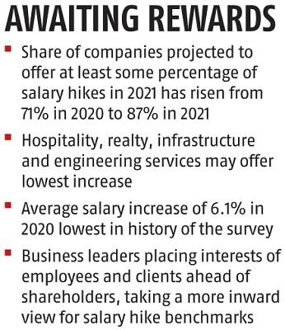

Apparently, the average salary increase of 6.1 per cent in 2020 is also the lowest in the history of the survey, even lower than 6.3 per cent recorded in the aftermath of the global financial crisis in 2008.

The rise in average hike from 6.1 per cent in 2020 to the projected 7.3 per cent in 2021 is also because a few organisations are not going for any increase in 2020, said Rattan.

On the other hand, two third of the surveyed companies either aim to provide similar or higher increments in 2021 compared to 2020. The survey says that close to 26.7 per cent of companies are projected to offer a higher salary increase in 2021, with another 39.8 per cent planning to offer the same hike as done in 2020. Close to 33.5 per cent of the companies intend to offer a lower [salary hike](https://www.business-standard.com/topic/salary-hike)in 2021.

According to Rattan, unlike in previous years when external factors had a bearing on [salary hike](https://www.business-standard.com/topic/salary-hike)decisions, organisations are now taking a more inward view for benchmarks post-Covid.

Further, recognising the fact that 2020 has been a “special year”, Nitin Sethi, partner at Aon and Chief Executive Officer of the firm’s ‘performance and rewards solutions’ practice in India, noted that business leaders were putting investments in their employees and clients ahead of shareholder returns.