Final Accounts of Sole proprietorship- Numerical

Problem 1.
The following trial balance has been extracted from the books of Abhinav & Sons on 31st March, 2019.
Particulars | Dr. Amount (Rs.) | Cr. Amount (Rs.)
Opening Stock | 21,250
Purchases | 67,500
Sundry Debtors | 22,000
Sales Returns | 1,250
Carriage Inwards | 1,450
Factory Rent & Taxes | 4,200
Manufacturing Wages | 20,800
Octroi | 1,650
Carriage outwards | 1,400
Salaries (administrative staff) | 17,500
Insurance Premium | 1,350
Office Rent | 2,200
Travelling Expenses | 6,200
Cash in Hand | 650
Cash at Bank | 8,950
Bills Receivable | 5,000
Furniture | 9,000
Machinery | 30,000
Interest Received |  | 900
Bad debts | 400
Commission Received |  | 1,000
Purchase returns |  | 1,400
Sundry Creditors |  | 15,500
Bills Payable |  | 4,000
Capital |  | 54,000
Sales |  | 1,45,950
 | 2,22,750 | 2,22,750

The following additional information is available.
- The closing stock was on 31st March 2018 is valued at Rs.30,500.
- Manufacturing wages and Office Salaries are outstanding as 2,500 and 2,000 respectively.
- Insurance premium of Rs.350 is prepaid.
- Provision for bad and doubtful debts is to be created at 5% on Debtors.
- Depreciation to be charged on Furniture and Machinery @10% and 15 % respectively.
You are required to prepare Trading Account, Profit and Loss Account for the year ended on 31st March 2019 and Balance Sheet as on that date.

Problem 2.
From the following Trial Balance, Prepare Trading and Profit & Loss A/c and Balance Sheet for the year ended 31st March, 2019.
 | Amount |  |  | Amount
Purchases | 2,50,000 | Sales |  | 8,80,000
Salary | 25,000 | Capital |  | 50,000
Rent | 40,000 | Loan |  | 1,90,000
Commission | 32,000 | Creditors |  | 79,000
Carriage Inward | 18,000 | Commission |  | 28,000
Bonus | 40,000
Debtors | 1,20,000
Cash | 15,000
Machinery | 4,50,000
Advertisement | 38,000
Factory Rent | 22,000
Interest | 15,000
Wages | 39,000
General Expenses | 8,000
Opening Stock | 1,00,000
Staff Welfare Expenses | 3,000
Printing & stationery | 12,000
 | 12,27,000 |  |  | 12,27,000
Adjustments:
- Closing Stock - Rs.20,000
- Calculate Depreciation on Machinery @ 12%
- Outstanding salary - Rs.2500
- Prepaid Advertisement - Rs.5,000

Problem3.
The under noted balances are extracted from the books of account of Anuj for the year ended 31st March, 2019

Adjustments:
Particulars | Rs. | Particulars | Rs.
Advertisement | 6,000 | Patents and trade marks | 7,200
Bad debts | 6,312 | Plant and machinery | 43,939
Bank overdraft | 33,412 | Power | 9,835
Bills payable | 18,315 | Purchases | 3,12,411
Bills receivable | 12, 846 | Purchase returns | 2,513
Buildings | 49,500 | Factory rent, rates and taxes | 7,358
Capital | 1,00,000 | Salaries | 14,915
Carriage inwards | 2,215 | Sales | 4,88,632
Carriage outwards | 3,780 | Commission received | 7,500
Cash in hand | 135 | Sales returns | 4,635
Dividends received | 4,500 | Stock on 1-4-2018 | 124,876
Drawings | 23,309 | Sundry creditors | 95,493
Furniture | 10,000 | Sundry debtors | 92,475
Insurance | 2,912 | Wages | 56,812
Investments at cost | 3,500 | 10% Loan taken from Bank Of India | 89,600
Loans given to employees | 45,000
a) Depreciation is to be provided on building at 10%; on plant and machinery at 15%; and on furniture at 10%.
b) Interest receivable on loans given to employees Rs.2,500.
c) Prepaid rent amounting to Rs.300 has been included in Factory rent, rates and taxes
d) Stock in hand on 31st March, 2019 was Rs. 129,757.
e) Further Bad debts is Rs. 5,500. A provision has to be made @5% on Debtors.
f) Anuj has withdrawn some stock costing Rs.3,500 for personal use.
g) Goods lost by fire worth Rs.5500 on 30-03-2013. Insurance company accepted a claim of Rs 3,000 and the cheque was received in April 2013.
h) Goods sent on Approval basis Rs 3,000 was wrongly recorded as Sales. The cost price of the goods was Rs 2,800.
Prepare the Trading and Profit & loss accounts & the Balance sheet of Anuj after using the above data.

Problem 4.
From the following trial balance of Mr. Santosh as at 31-12-2019, prepare final accounts after taking into account the following adjustments.

Particulars | Dr. Rs. | Cr. Rs.
Capital a/c |  | 30,000
Drawing a/c | 2,600
Plant & machinery a/c | 12,000
Opening stock | 5,000
Purchase | 35,000
Sales |  | 48,000
Returns inwards | 2,000
Return outwards |  | 1,000
Sundry debtors | 8,000
Sundry Creditors |  | 6,000
Carriage inwards | 500
Carriage outwards | 500
Wages | 3,000
Salaries | 2,000
Factory rent | 200
Office rent | 500
Insurance | 500
Provision for Bad debts |  | 600
Discount allowed | 300
Furniture | 2,000
Bad debts | 400
Commission | 300
Building | 8,000
5% Term loan |  | 4,000
Bills receivable | 6,000
Cash on hand | 200
Cash at bank | 600
 | 89,600 | 89,600

Adjustments:
1) Closing stock was valued at Rs 20,000 and the market price for the same was Rs 25,000.
2) Insurance prepaid for the year is Rs.200.
    - Outstanding wages for the year were Rs.300 and Outstanding salary was Rs.200.
    - Additional bad debts for the year Rs.400 and the firm want to maintain Reserve for bad debts @5% on Debtors.
    - The proprietor has taken goods worth Rs.500 for personal use and distributed goods worth Rs.300 as samples.
    - Depreciation on Furniture and Plant & Machinery is to be provided @ 10% pa.
    - Goods lost due to fire Rs.500 & insurance admitted a claim for Rs 250 which is yet to be received.

Problem 5
Given below are the balances of Pandian as on 31st March, 2019.
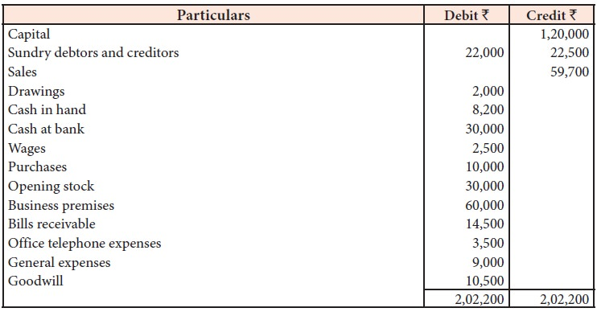
Adjustments:
- The stock value at the end of the accounting period was Rs. 50,000
- Write off bad debts amounting to Rs. 2,000 and Create provision for bad and doubtful debts on sundry debtors @ 10%
- Outstanding wages for the year was Rs.500
- Provide depreciation @10% on Business premises
- Write off Goodwill @20%
- Unexpired telephone expenses were Rs.600.

Prepare final accounts for the year ended 31st March, 2019.

Problem 6.
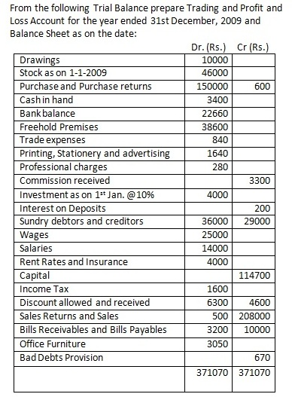
Adjustments:
1. Provide for wages Rs.5000.
2. Write off 5% depreciation on freehold premises and 10% on office furniture.
3. Insurance to the extent of Rs.200 belongs to 2010.
4. Closing stock as on 31.3.2010 is Rs.52000.

