ITM BUSINESS SCHOOL, NAVI MUMBAI
Physical distribution (or logistics) consists of all activities involved in moving the right amount of the right products to the right place at the right time
Physical distribution: Moving tangible products through distribution channels
Rise of e-commerce has underscored the importance of physical distribution
- relates to fulfillment, having the merchandise that is ordered by a customer, in stock
- then packing and – shipping it in an efficient, timely manner
ITM BUSINESS SCHOOL, NAVI MUMBAI
Most businesses use third parties or
intermediaries to bring their products to market.
Why does a business give the job of selling its products to intermediaries?
ITM BUSINESS SCHOOL, NAVI MUMBAI
DISTRIBUTION CHANNEL
DEFINED
ITM BUSINESS SCHOOL, NAVI MUMBAI
▪ A "distribution channel" which can be defined as “All the organizations through which a product must pass between its points of production and consumption”
▪ Channel decisions
✓affect other marketing decisions
✓involve long-term
commitments
IMPORTANCE OF INTERMEDIARIES
▪ Greater efficiency in making goods available to target markets.
▪ Intermediaries provide
▪ Contacts
▪ Experience
▪ Specialization
▪ Scale of operation
▪ Match supply and demand.
ITM BUSINESS SCHOOL, NAVI MUMBAI
MAJOR
ROLE/FUNCTIONS OF MARKETING
CHANNELS
ITM BUSINESS SCHOOL, NAVI MUMBAI
▪ • 4 functions of marketing channels:
▪ Facilitate exchange process by reducing no. of marketplace contacts necessary to make a sale (Filling gaps)
▪ Adjust for discrepancies/ Bulk breaking in the market’s
assortment of goods and services via sorting, channeling products
▪ Standardize payment terms, delivery schedules, prices,
purchase lots, and other
conditions.
▪ Facilitate searches by both buyers and sellers and bring them
together to complete the
exchange process.
▪ Information
▪ Promotion
▪ Contact
▪ Matching
▪ Negotiation
▪ Physical Distribution ▪ Financing
▪ Risk taking
ITM BUSINESS SCHOOL, NAVI MUMBAI
▪ Filling the gaps between production & consumption process:
1. Time gaps
2. Space gaps
3. Quantity gaps
4. Variety gaps
ITM BUSINESS SCHOOL, NAVI MUMBAI
GAP
FILLING BY CHANNELS
TYPES OF MARKETING CHANNELS
• Most channel options involve at least one marketing intermediary, an organization that operates between producers and consumers or business users.
• A retailer- owned and operated by someone other than the manufacturer of the products it sells.
• A wholesaler- who takes title to the goods it handles and then distributes these goods to retailers, other distributors, or sometimes end consumers.
• Service firms- market primarily through short channels because they sell intangible products and need to maintain personal relationships within their channels.
ITM BUSINESS SCHOOL, NAVI MUMBAI
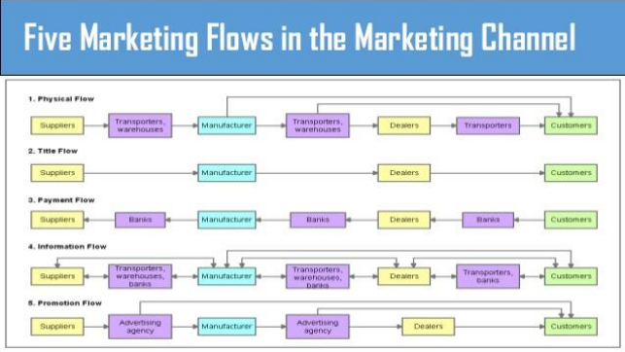ITM BUSINESS SCHOOL, NAVI MUMBAI
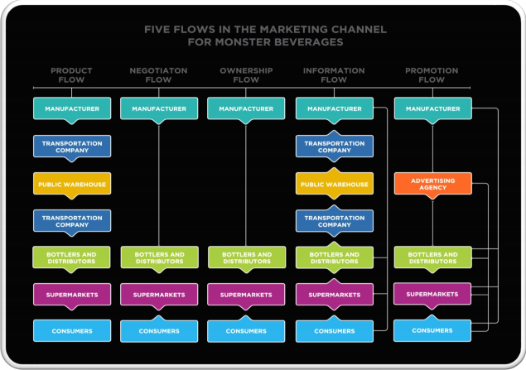ITM BUSINESS SCHOOL, NAVI MUMBAI

1. Number of
levels in the channel

2. Intensity at the
various levels

3. Types of
intermediaries
at each level
ITM BUSINESS SCHOOL, NAVI MUMBAI
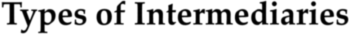

▪Numerous types
▪Manager’s emphasis on types of distribution tasks performed by these intermediaries
▪Few emerging types
▪ Electronic online auction firms (eBay)
▪ Industrial products sold in B2B markets
ITM BUSINESS SCHOOL, NAVI MUMBAI
▪ Distributors
▪ Wholesalers
▪ Retailers
▪ Department stores ITM BUSINESS SCHOOL, NAVI MUMBAI
▪ CHANNEL LEVELS 1. Zero level 2. One level 3. Two level
4. Three level

▪Range from two to five or more
▪Number of alternatives is limited to two or three choices
▪Limitations result from the following factors: ▪ Particular industry practices
▪ Nature & size of the market
▪ Availability of intermediaries
ITM BUSINESS SCHOOL, NAVI MUMBAI
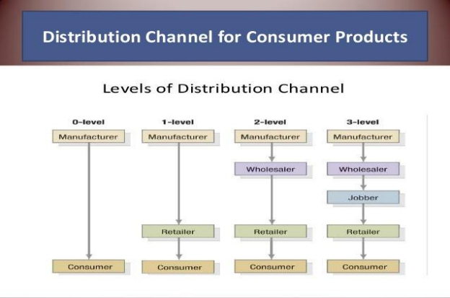ITM BUSINESS SCHOOL, NAVI MUMBAI
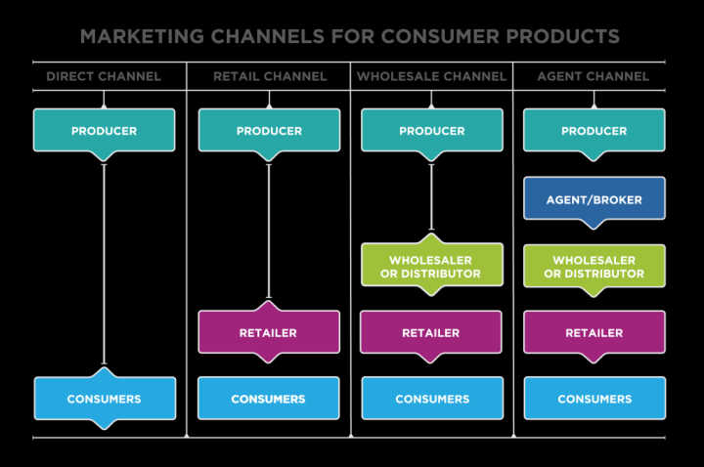ITM BUSINESS SCHOOL, NAVI MUMBAI
MAJOR
Marketing
intermediaries ITM BUSINESS SCHOOL, NAVI MUMBAI
▪ Four basic types of marketing intermediaries :
AGENT -
➢ Is an independent individual or company whose main
function is to act as the
primary selling arm of the
producer and represent the producer to users.
➢ Agents take possession of products but do not
actually own them.
➢ Agents usually make
profits from commissions
or fees paid for the
services they provide to
the producer and users.
WHOLESALERS ITM BUSINESS SCHOOL, NAVI MUMBAI
- Wholesalers are
independently owned firms that take title to the merchandise they handle.
➢ The wholesalers own the products they sell.
➢ Wholesalers purchase product in bulk and store it until they can resell it.
➢ Wholesalers generally sell the products they have
purchased to other
intermediaries, usually
retailers, for a profit.
- Distributors are like wholesalers, but with one key difference.
➢ Wholesalers will carry a variety of competing products, for instance Pepsi and coke products, whereas distributors only carry complementary product lines, either pepsi or coke products.
➢ Distributors usually maintain close relationships with their suppliers and customers.
➢ Distributors will take title to products and store them until they are sold.
ITM BUSINESS SCHOOL, NAVI MUMBAI
A retailer takes title to, or purchases, products from other market intermediaries.
➢ Retailers can be independently owned and operated, like small “mom and pop” stores, or they can be part of a large chain
➢ The retailer will sell the products it has purchased directly to the end user for a profit.
ITM BUSINESS SCHOOL, NAVI MUMBAI
DUAL DISTRIBUTION
• Movement of products through more than one channel to reach the firm’s target market.
• Used to maximize the firm’s coverage in the marketplace or to increase the cost-effectiveness of the firm’s marketing effort.
REVERSE CHANNELS
• Channels designed to return goods to their producers.
• Growing importance because of rising prices for raw materials, increasing availability of recycling facilities, and passage of additional antipollution and conservation laws.
• Also used for recalls and repairs.
ITM BUSINESS SCHOOL, NAVI MUMBAI
▪ Intensive
▪ Selective
▪Exclusive
ITM BUSINESS SCHOOL, NAVI MUMBAI
Intensive distribution - Distribution of a product through all available channels.
Selective distribution - Distribution of a product through a limited number of channels.
Exclusive distribution- Distribution of a product through a single wholesaler or retailer in a specific geographic region.
ITM BUSINESS SCHOOL, NAVI MUMBAI
✓Marketers have relationships with intermediaries in distribution channels.
✓Tasks in Channel Management:
▪ Selecting channel members
▪ Training channel members
▪ Motivating channel members
▪ Modifying channel arrangement
ITM BUSINESS SCHOOL, NAVI MUMBAI
▪ With time, channels need to change along with product as it get older in the PLC
▪ Introduction – boutiques, company showrooms ▪ Growth – chain stores, departmental stores
▪ Maturity – Mass merchandisers
▪ Decline – ‘sales stores’, discount stores
ITM BUSINESS SCHOOL, NAVI MUMBAI
➢Channel captain - Dominant and controlling member of a marketing channel.
➢Interest of different business interests do not necessarily coincide
▪ Conflicts can occur at various levels
✓ vertical
✓ horizontal
✓ multichannel
ITM BUSINESS SCHOOL, NAVI MUMBAI
▪Goal incompatibility ▪Differences in perception ▪Great dependence
ITM BUSINESS SCHOOL, NAVI MUMBAI
• Horizontal conflict—disagreements among channel members at the same level, Eg.- two competing discount stores.
• Vertical conflict occurs among members at different levels of the channel.
➢ • The gray market—goods produced for overseas markets that re-enter the market and compete against domestic versions.
ACHIEVING CHANNEL COOPERATION
• Best achieved when all members of channel see themselves as equal components; channel captain should provide this leadership.
ITM BUSINESS SCHOOL, NAVI MUMBAI
Retailing
ITM BUSINESS SCHOOL, NAVI MUMBAI
✓Includes all activities involved in selling goods or services directly to final consumers.
✓Types of Retailers
▪ Self service – discount stores (no assistance)
▪ Self selection – dept. store (assistance is available if
required)
▪ Limited service – counter
salesmen are present.
▪ Full service – Co. showrooms. Salesmen are available to explain, demonstrate, give technical help and promote the products
Wholesaling
▪ Includes all activities involved in selling goods and services for resale or business use.
▪ They are the intermediaries between manufacturers and retailers.
ITM BUSINESS SCHOOL, NAVI MUMBAI
▪ Less attention to promotion, atmosphere and location
▪ Transactions are usually large and cover a wider geographical area
▪ Could have different tax implications, regulations,etc. because of its status as a wholesaler
ITM BUSINESS SCHOOL, NAVI MUMBAI
▪ Financing
▪ Risk bearing
▪ Market information
▪ Management services and counselling
ITM BUSINESS SCHOOL, NAVI MUMBAI
▪ Selling and promoting
▪ Buying and assortment building
▪ Bulk breaking
▪ Warehousing
▪ Transportation
▪ Involves the planning, implementing and controlling the physical flows of materials and final goods from point of origin to points of use to meet customer requirements at a profit.
▪ It involves materials management, distribution systems and IT systems interlinked with one another
ITM BUSINESS SCHOOL, NAVI MUMBAI
▪ Order processing
▪ Warehousing
▪ Inventory
▪ Transportation
ITM BUSINESS SCHOOL, NAVI MUMBAI
VERTICAL MARKETING SYSTEMS
• Vertical marketing system (VMS) Planned channel system designed to improve distribution efficiency and cost-effectiveness by integrating various functions throughout the distribution channel.
CORPORATE AND ADMINISTERED SYSTEMS
• Corporate marketing system—single owner runs(own) organizations at each stage of the marketing channel.
• Administered marketing system—dominant channel member exercises power to achieve channel coordination.
CONTRACTUAL SYSTEMS
• Contractual marketing system—coordinates distribution through formal agreements among channel members.
• Include wholesaler-sponsored voluntary chains, retail cooperatives, and franchises.
ITM BUSINESS SCHOOL, NAVI MUMBAI
Channel Design:
Decisions involving the development of new marketing channels either where none had previously existed or the modification of existing channels
ITM BUSINESS SCHOOL, NAVI MUMBAI
▪ Setting distribution objectives requires knowledge of - which existing objectives …….& strategies may impinge on these distribution objectives.
ITM BUSINESS SCHOOL, NAVI MUMBAI
A decision made by the marketer
The creation or modification of channels
The active allocation of distribution tasks in an attempt to develop an efficient structure
The selection of channel members
A strategic tool for gaining a differential advantage
ITM BUSINESS SCHOOL, NAVI MUMBAI
ITM BUSINESS SCHOOL, NAVI MUMBAI
1. Recognize the need for
channel design decision
7. Select
channel members
6. Choose the “best” channel structure
5. Evaluate
relevant variables
2. Set & coordinate
distribution objectives
3. Specify
distribution tasks
4. Develop alternative
channel structures
ITM BUSINESS SCHOOL, NAVI MUMBAI
▪ Developing a new product or product line
▪ Aiming an existing product at a new market
▪ Making a major change in some other component of the marketing mix
▪ Establishing a new firm
▪ Adapting to changing intermediary policies that may inhibit
attainment of distribution
objectives
ITM BUSINESS SCHOOL, NAVI MUMBAI
▪ Dealing with changes in availability of particular kinds of intermediaries
▪ Opening up new geographic marketing areas
▪ Facing the occurrence of major environmental changes
▪ Meeting the challenge of conflict or other behavioral problems
▪ Reviewing and evaluating
Categories of Variables1. Market Variables
2. Product Variables
3. Company Variables
4. Intermediary Variables
5. Environmental Variables
6. Behavioral Variables
ITM BUSINESS SCHOOL, NAVI MUMBAI
Market Geography Location, geographical size,& distance from producer
Market Size Number of customers in a
market
Market Density Number of buying units
(consumers or industrial firms)
per unit of land area
Market Behavior Who buys, & how, when, and where customers buy
ITM BUSINESS SCHOOL, NAVI MUMBAI
Bulk & Weight
Perishability
Unit Value
Degree of Standardization
Technical versus Nontechnical
Newness
ITM BUSINESS SCHOOL, NAVI MUMBAI
Size The range of options is
relative to a firm’s size
Financial The greater the capital, the Capacity lower the dependence on intermediaries
Managerial Intermediaries are necessary Expertise when managerial experience is lacking
Objectives Marketing & objectives may & Strategies limit use of intermediaries
ITM BUSINESS SCHOOL, NAVI MUMBAI
Availability Availability of intermediaries
influences channel structure.
Cost Cost is always a consideration in
channel structure.
Services Services that intermediaries offer are closely related to the selection of channel members.
ITM BUSINESS SCHOOL, NAVI MUMBAI
Economic
Sociocultural
Competitive
The impact of environmental forces is
a common reason for making
channel design decisions.
^{Technological} Legal
ITM BUSINESS SCHOOL, NAVI MUMBAI

