Microsoft Corporation
Microsoft Corporation is an American technology company. It develops, manufactures, licenses, supports and sells computer software, consumer electronics, personal computers, and related services.

Their mission is to 'empower every person and every organization on the planet to achieve more.'

Microsoft's Integrated Marketing Communication Channels:
Print and media are a pivotal part of Microsoft's marketing strategy. Microsoft spends upwards of $1.5 Billion for Print and media alone.


One of its ingenious print advertising campaigns for Microsoft's Office 365 software includes the WiFi-enabled promotion on the Forbes magazine.

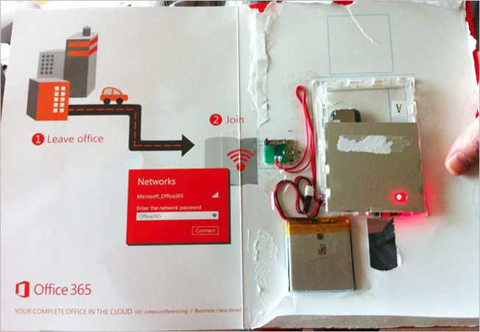
A sleek router with a battery placed within the magazine gave its subscribers free wifi for 15 days. This gimmick ensured that readers had to retain the magazine him at all times and contributed multiple exposures of the ad to the reader. Currently, Microsoft is undertaking a slow shift from traditional media to social media and other online platforms.
Microsoft's Integrated Marketing Communication Approach:
Microsoft has been continuously taking up several Artificial Intelligence (AI) projects and has placed AI high up in its product portfolio. To promote its AI offerings, Microsoft teamed up with Carlsberg to use AI to speed up the process of brewing new flavors of the beer.
The company has marketed this project using the integrated marketing approach using a multitude of channels.

Twitter
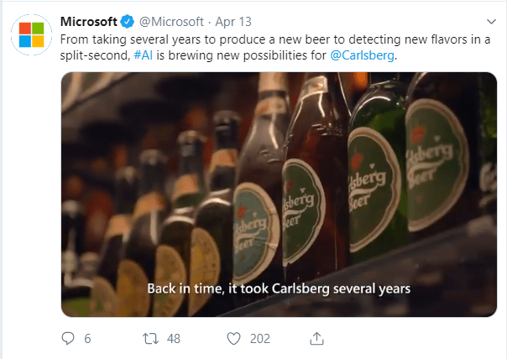

Video Promotions across - Facebook and Youtube



Press releases in popular newspapers such as Financial Times.

