Methods of Pricing on the Basis of Cost, Competitors and Marketing Orientations!
Being merely a number, it might be tempting to believe that setting the price of a product must be an easy task for a company to perform. It is not. Many external and internal factors have to be considered together.
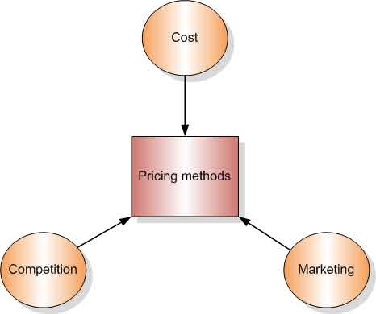
Image Courtesy : staffs.ac.uk/sgc1/faculty/market-for-mans/images/pricing-methods.png
ADVERTISEMENTS:
The price should have some reference to its costs, as they must be recovered at least in the long run. Most companies cannot afford to sell at prices below cost for long periods. The price should be low enough to attract customers but high enough to’ bring reasonable profits to the company.
A company might be tempted to maximize profits by charging higher prices, but the customers may not consider the products worthy of the higher prices being charged and may not buy at all. The price should match the positioning strategy of the company.
The value of a premium brand will be eroded if its price is low. In most situations, all the above factors have to be considered simultaneously when prices are set.
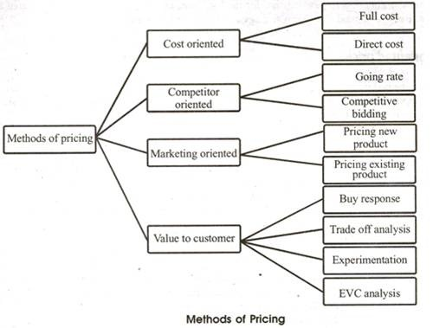

Cost-oriented pricing:
One of the methods of pricing a product is on the basis of its cost. The company can either set the price on the basis of the total cost of the product, or on the basis of its variable cost.

Full cost pricing:
Variable and fixed cost per unit is added and the desired profit margin is added to the total cost. This price is true for a given volume of sales/output. But if sales/output goes down, fixed cost per unit goes up, so price should go up.
Therefore, there is an increase in price as sales fall. Sales estimates are made before a price is set which is illogical. It focuses on internal costs rather than customer’s ability or willingness to pay. There may also be technical problems in allocating fixed/overhead cost in multiproduct firms.
In spite of its drawbacks, the method forces managers to calculate costs, so it gives an indication of the minimum price necessary to make a profit. Breakeven analysis can be used to estimate sales volume needed to balance revenue and costs at different price levels.

Direct cost pricing:
The desired profit margin is added to the direct cost to obtain a price. Price does not cover full costs, and the company would be making a loss. The strategy is valid if there is idle capacity as margin is covering some part of fixed costs.
It is useful for services in periods of low demand as they cannot be stored. But customers who have paid higher amount may find out and complain. Direct cost indicates the lowest price at which it is sensible to take business if the alternative is to sit idle. It does not suffer from ‘price up as demand goes down problem’, as it happens in full cost pricing method.
It also avoids problem of allocating overhead charges. But when business is buoyant, it does not take into account customers’ willingness to pay. It is not for the long term as fixed cost must also be covered to make profits. But it is a good short-term strategy to reduce impact of excess capacity.

Competitor-oriented pricing:
Another method of pricing a product is on the basis of the competitor’s price. A company can operate at a competitor’s price level if its products are undifferentiated. It may adopt a more aggressive stance by lowering its price to win bids, or to get a larger market share.

Going rate pricing:
There is no product differentiation, i.e., there is some sort of perfect competition. All companies charge the same price and smaller players follow the price set by market leaders. This is not an attractive proposition for marketers.
ADVERTISEMENTS:
Marketers like to differentiate their offerings and have a degree of price discretion. Even for commodity products, differential advantages can be built upon for which premium prices can be charged.

Competitive bidding:
The usual process involves drawing up a detailed specification for a product and putting it out for tender. Potential suppliers quote a price which is confidential and known only to themselves and the buyer (sealed bid). A major focus for suppliers is the likely bid prices of competitors.
Expected profit = Profit x Probability of winning As the quoted price will increase, profits will rise, but the probability of winning the bid will fall. The bidder uses past experience to estimate a probability of clinching the deal at each price level. Expected profit peaks at a particular bid price.
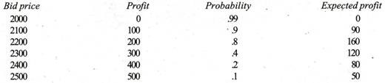
The company would quote a price of $2,200 as it stands to make the maximum profit at this price with 80 per cent probability of winning the bid. But calculation of probability of succeeding goes haywire where competitors are desperate to win an order.
Such competitors would quote very low prices to win the bid, as they are willing to take the lower profits. A successful bidder needs to be aware of competitors’ motives and circumstances, and therefore it needs to install a competitor information system.
It needs to be aware of competitors who have idle capacity because such competitors will quote low prices to win a bid, so that they can utilize their idle capacity.
Salespeople need to be trained and motivated to feed details of past successful and unsuccessful bids. They should be trained to elicit successful bid prices from buyers and then motivated to enter them into a database which records order specification, quantities and successful bid price. But not all buyers will reveal true figures so the buyers have to be graded for reliability.

Marketing oriented pricing:
Prices should be in line with marketing strategy. Price should be linked to positioning, strategic objectives, promotions, distribution and product benefits. Pricing decision is dependent upon other earlier decisions in the marketing planning process. For new products, price will depend upon positioning strategy and for existing products, price will be affected by strategic objectives.

Pricing new products:
(i) Positioning strategy:
For a new product there is an array of potential target markets. For calculators, the target market world comprise engineers and scientists, bankers and accountants, and general public.
Choice of target market would have an impact on price that could be charged. If engineers were targeted, price could be higher. For accountants, price would be lower and for the general public, it would be still lower.
A company would slowly reduce its price to attract other segments, or it can continue to serve the segment which places higher value on its product, and hence continues to pay higher price.
Therefore, for a new product, a company must decide its target market, and estimate the value that customers place on the product. A new product is successful if the price that it sets reflects the value that the customers place on the product.
When a company has multiple target markets, it introduces modified versions of the product in each one of its target markets, and prices each version in line with respective values that each target market places on the product.
When a company decides to launch different versions of a product, at different prices, targeted at different target markets, it should check if the customers of the more premium version will trade down once cheaper versions are available.
An engineer will buy a scientific calculator even if it is very highly priced in comparison to simpler calculators because the latter will not serve his purpose. If different versions cannot be sufficiently differentiated to be able to keep their customers, a company should desist from launching simpler and cheaper versions for as long as possible, because the customers who had hitherto bought the premium version will start buying the cheaper version, as these too will serve his purpose sufficiently.
(ii) A combination of high price and high promotion expenditure is called rapid skimming strategy. The high price provides high margins and heavy promotion causes high level of product awareness and knowledge. A slow skimming strategy combines high price with low levels of promotional expenditure.
High price means big profit margins but high level of promotion is believed to be unnecessary, perhaps because word of mouth promotion is more important and product is already well known, or because heavy promotion is thought to be incompatible with the product image as with cult products. This strategy, (i.e., skimming) is useful if there is patent protection.
A company practices rapid penetration strategy if it combines low prices with heavy promotional expenditure. Its aim is to gain market share rapidly, perhaps at the expense of a rapid skimmer. Slow penetration strategy combines a low price with low promotional expenditure.
Own label brands use this strategy. Promotion is not necessary to gain distribution and low promotional expenditure helps to maintain high profit margins.
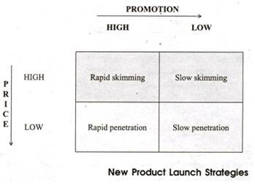
(iii) It is important to understand the characteristics of market segments that can bear high prices. The segment should place a high value on the product which means that its differential advantage is substantial. Calculators provide high functional value to engineers and they will be willing to pay high prices for them.
Perfumes and clothes provide psychological value and brand image is crucial for such products to be acceptable. High prices go well with premium brand image. High prices are also more likely to be viable where consumers have a high ability to pay.
A company can afford to price its products at higher levels if the consumer of the product is different from the person who pays for it. Products for children or stationery items for a company’s employees come under this category. The user simply focuses on the suitability of the product and does not bother much about the price when selecting a product.
A company can also afford to charge a high price if there is lack of competition among supplier companies. The company does not fear that its customers will switch over to competitors because of its high prices.
A company can also charge a high price from its customers if there is high pressure on them to buy. A business traveller rushing to meet a deadline with a customer will be willing to pay a much higher price for an air ticket than a normal passenger who is not so hard pressed.
(iv) Low price is used when it is the only feasible alternative. Product may have no differential advantage, customers are not rich and pay for themselves, have little pressure to buy and have many suppliers to choose from. A company cannot charge a premium price for such a product and it has to be content with charging a going rate price.
But if a company wants to dominate its market, it has to price aggressively to attract customers from competing brands. Since the product does not have any meaningful differential advantage, the only way to increase market share is by lowering price. But such a strategy cannot work if it does not have a low cost structure.
A company which seeks to dominate a market through aggressive pricing should use new technologies to produce and distribute its product at a lesser cost. It should always achieve economies of scale.
A company can increase its price once it has garnered a satisfactory level of market share, but it may not always be a good idea since customers may feel that the product is not differentiated enough to deserve premium pricing. It should instead earn its money on after sales sendee and spare parts.
(v) Price sensitivity of customers may change over time. When products are novel, customers are willing to buy them at higher prices because it serves their unique requirements or provides self-esteem.
But when the same product becomes widely used, customers start considering the price as important element in their choice criteria. Also when customers’ income increases, products about which they were price sensitive are bought without much regard to its price.

Pricing existing products:
Strategic objective for each product will have major bearing on pricing strategy. For example, if a company wants to develop a premium brand it will price its products higher, but if it wants to capture the mass market, it will have to price its products lower.
i. Build objective:
The company wants to increase its market share. In price sensitive markets, the company has to price lower than competition. If competition raises prices, the company should be slow to match them. But if competition reduces prices, it promptly matches or undercuts it further.
For price insensitive products, price will depend on the overall positioning strategy appropriate for the product. If the product is positioned as premium, it will have to be priced higher but if the product is targeted at the mass market, the price has to be lower and competitive.
ii. Hold objective:
The company wants to maintain its market share and profits. The company’s pricing policies are essentially reactionary in nature. The company maintains or matches price relative to the competition.
The company reduces price if competition reduces price in order to hold sales or market share. If the competition increases price, the company also increases its price, as it does not want to compromise on its profitability.
iii. Harvest:
The company is focused on increasing its revenues. It wants to maintain or raise profits even if sales fall. The company sets premium prices in order to achieve this objective. It does not match competitor’s price cuts, but price increase is swiftly matched. The company is proactive in revising its prices upwards.
iv. Repositioning strategy:
Price change will depend on the new positioning strategy. If the objective is to build a premium brand, the company will price its product higher, but if the company wants to reposition the product for the mass market, it will have to lower its price and make it competitive.
A company cannot set its price in isolation. The pricing policy of a company is instrumental in achievement of its financial and strategic goals.
The pricing policies of a company also send strong signals to customers about the positioning plank of the company. Therefore price can be decided only after knowing the positioning strategy and strategic objective.

Value to the customer:
Price should be accurately keyed to the value to the customer. The more value that a product gives compared to the competition, the higher the price that can be charged.
There are four ways of estimating value to the customer:

Buy response method:
A company asks customers if they would be willing to buy at varying price levels. Up to ten prices are chosen within the range usual for the product. Respondents are shown the product and asked if they would buy the product at, say $100. The first price quoted is near the average for the product category and other prices are stated at random.
The percentage of respondents indicating that they would buy is calculated for each price and plotted to form the buy-response curve. The curve shows the prices at which willingness to buy drops sharply and give an indication of acceptable price range.
The methodology focuses on respondent’s attention exclusively on price, which may induce an unrealistically high price consciousness. But the method gives the company a good idea of the value that the customers place on the company’s product.
Customers weigh price against product features and benefits of the company’s products and competitors’ offerings. If a competitor has launched a product with more features and benefits at a lesser price, customers will take into consideration the existence of a better product at a lesser price, and will value the company’s product’s lower.

Trade-off analysis:
A company creates product profiles, in which it describes product features and prices, and then asks respondents their preferred profile. When a customer evaluates product profiles, he sees price as just one part of the offering, and his choice reveals the trade-offs that he is willing to make between features and price.
The company analyses customers’ preferences for particular profiles, and is able to gauge the relative importance of each feature, and also its price. After knowing the customers’ preference for product attributes and the price they are willing to pay for them, the company can create the right combination of product features and price.
A limitation of this method is that respondents are not asked to back up their preferences by being- required to buy their preferred combination of features and price. They may not buy their preferred choice when they are actually making a purchase.

Experimentation:
During experimental pricing research, a company sells the same product in different stores and at different prices. In a controlled store experiment, stores are paid to sell the product at different prices. For example, a company selects 200 stores to test two prices. It chooses 100 stores at random and allocates them the lower price, and the rest are allocated the higher price.
The company compares the sales and profit between the two groups of stores, and it decides the price at which it will earn maximum profits. A variant of experimental pricing research tests the impact of price differences between the company’s brand and a competitor brand.
The company offers a price differential of say, Rs. 10 in one half of the stores and Rs. 20 in other half of the stores. The company analyses how the difference in price between its brand and the competitor brand impacts sales, and decides an appropriate price for its product.
In test marketing, a company sells the same product in two areas using an identical promotional campaign, but keeps the prices different in the two areas. The two areas should match in terms of target customer profile so that results can be compared, i.e., difference in sales in the two areas can be attributed to difference in prices.
It needs to carry out the test for a long enough periods so that trial and repeat purchase at each price can be measured. But it should be wary of competitors, who may act to invalidate the results. They may launch special promotional programmes in the test areas, making it difficult for the company to attribute its sales figure to the price it is charging.
This distortion is especially possible, when product is not highly differentiated and therefore introducing a cheaper version would make a premium buyer buy that cheaper version.

Economic value to customer (EVC) analysis:
Experimentation is more useful in consumer products. EVC analysis is used for industrial products. Economic value to the customer is the value that industrial buyer derives from the product in comparison to the total costs that he incurs in procuring and operating the product.
A high EVC may be because the product generates more revenues for the buyer than competition or because its total cost of procurement plus operating costs are lower over the product’s lifetime (Price = Setup costs, i.e., purchase cost + operating costs).
If a company has an offering that has high EVC, it can set a high price and yet offer superior value compared to competition, as the operating cost of the customer is lower or the customer is able to derive greater value from the product.
The essential idea is that a company buys a product to enable it to earn revenues at as less an expenditure as possible. So a product with high EVC is preferred by industrial customers. The EVC analysis is particularly revealing when applied to products whose purchase price represents a small proportion of the lifetime costs to the customer.

