Course: Operations Management.
Topic: New Product Design
Case study of Kia Motors - Design and Quality

With stunning design and superlative quality, this new player (Kia Motors) is about to change the Indian car scene
Courtesy: Samin Sayeda | SPOTLIGHT | Apr 23, 2019, TOI
When it comes to design, inspiration can come from anywhere. It is one’s vision to instill soul into an idea that can make the simplest things significant. Beyond assembling and editing, it is the ability to add meaning, dramatize, persuade, and trigger an emotional response that makes a work of art shine. In the automobile manufacturing space as well, design plays a pivotal role. While there are unifying themes and common attributes that most car makers stick to, it is necessary to go beyond uniformity to cater to the needs of discerning car buyers.
As the world’s fifth-largest auto market, the Indian automotive landscape has seen immense transformation. Indians are becoming increasingly receptive to innovations as well as to new entrants in the car market that hold the potential to unite premium design with the varied needs of car owners. Many car makers are also reinventing their cars to bring to customers a differentiation factor. To tap into the growing demands of this expanding market, global automobile major Kia Motors is finally making its entry into India with design as the primary game-changer.
Having sold over 3 million cars worldwide in 2018, Kia Motors is one of the fastest growing brands across many global markets. Its foray into the Indian market will be a step-change in the country’s auto industry that has predominantly been traditional in its designs and aspirations. What further reinforces the Indian customers’ belief in the South Korean brand is the fact that Kia made its mark in a highly volatile European market, where it managed to significantly stir the automotive landscape. In India, Kia is set to enter with a futuristic design strategy coupled with competitive prices compared to the other players in the market. To attain this vision and to make the brand exciting and fun, Kia has been interacting with customers to garner an extensive understanding of its markets and the technologies that exist there.
Customer-centric design philosophy
Kia’s trajectory of design superiority has steadily scaled upwards in the last decade mostly because they have worked on a customer-first approach. Car owners understandably have many questions before buying a car. They’re concerned about the range, whether these cars will be dynamic and fun to drive, and if the automotive design can make these vehicles stand out in the crowd. So, when Kia first started reinventing its design philosophy, it looked at design from an emotional point of view. Its study of design went beyond art, architecture, ergonomics, and industrial design and instead focused on how these elements can influence people. This approach went a long way in understanding consumer concerns and helped Kia Motors formulate an unorthodox design approach that has stemmed from the collective imagination of its design engineers.
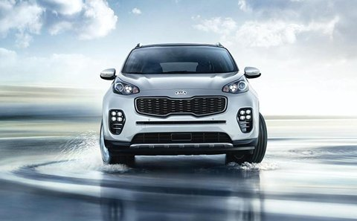

Tiger-nose grille as a visual identifier and an identity for car owners
As one of the distinctive elements of design in Kia cars, the Tiger-nose grille has been carried across its entire product line-up. This design signifies adaptability as one of the dominant elements of design in Kia cars. Interestingly, the size of the Tiger-nose grille can be adjusted along with the positioning of the lights around, but even after these alterations, one look at a Kia car would reveal the essence of its design. This way, designers at Kia have kept the set template of cars consistent, while also providing car owners with enhanced freedom of expression.
Reinforcing the importance of the straight line as one of the finer elements of Kia’s design
Kia's design philosophy has been significantly structured around the simplicity of straight lines. Straight lines are the metaphors for clarity and precision and through it, designers at Kia have asserted the simplistic structure and meticulous details of the interiors and exteriors of Kia cars.
Tailor-made design concepts for different car models
The ultimate goal of Kia's styling activities is to create complete and unprecedented designs for car owners. In a quick and demanding automotive market, customer needs and expectations are constantly evolving. To take care of that, Kia's vehicles remain flexible to these demands, an approach that has enabled them in designing eclectic cars for different categories of people. This design treads on the idea that cars are designed keeping in mind global and local requirements and its foray into the Indian space will strike a chord with the new age customers in the country. Kia’s vehicles in India will be tuned to suit specific driving conditions in the country.
A consistent arrangement of elements
The essence of Kia design is also based on consistency. Thus, in Kia cars, the signature grille, headlamps and brand logo represent a strong, unified theme. This lends Kia design an element of reliability through which it has managed to unite the product with its customers. In the Indian market as well, this element is set to yield preference and likeability.
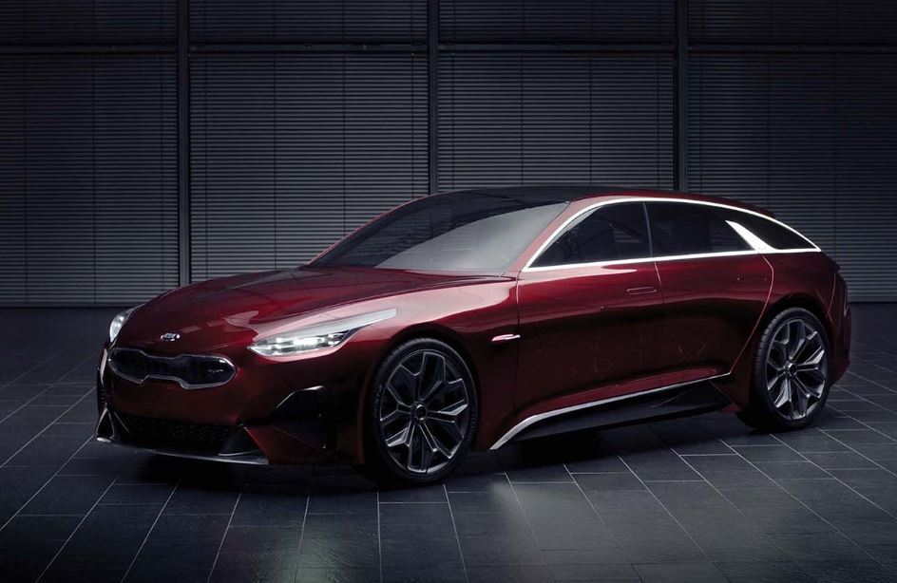
Leading up to the launch of Kia in India, the brand has launched a campaign that aptly brings out the importance of design in the Kia ecosystem. It released its first ever campaign in India titled, ‘Magical Inspirations, Stunning Designs’ that combines majestic elements inspired from nature, technology, and space. This unique synchronization of design elements gives us a picture of how Kia will bring about a step change in the auto landscape in the country.
Kia motors as a brand, is revered and recognized for its world-class and unique award-winning designs globally and it is not a surprise that it is the fastest company to win 70+ design awards in the world. In the international market, Kia has always had a loyal following with interesting ownership stories that evidence the dependability and affordability of Kia cars. Its cutting-edge design philosophy, that has resulted in some of the most iconic cars of this generation, is sure to strike a chord with the evolved Indian consumer giving rise to new aspirations in the growing auto-map in the country.
Questions: 1. What is the design philosophy of Kia motors?
2. What are the unique features of Design of Kia motors?
3. Explain in brief the world-wide achievements of Kia motors.
3. Analyze and explain the strategy of Kia motors for the Indian market.
Compiled by Prof B.V.R. Murty.

